|  |  |
| --- | --- |
|  | FPT ACADEMY INTERNATIONAL  FPT – APTECH COMPUTER EDUCATION |

Centre Name: ACE-HCMC-2-FPT.

Address: 590 Cach Mang Thang 8, District 3, Ho Chi Minh City, Viet Nam.

**[Happiness]**

|  |  |  |
| --- | --- | --- |
| Supervisor: | Phạm Thị Lánh | |
| Term: | 1 | |
| Batch No: | T1.2208.M0 | |
| Group No: | 4 | |
| Order: | Full name | Roll No. |
| 1. | Trần Văn Phát | Student1398823 |
| 2. | Phan Văn Khải | Student1405224 |
| 3. | Lê Trần Huy Hiển | Student1396936 |

Month 10 Year 2022

This is to certify that

**Mr. TRẦN VĂN PHÁT**

**Mr. PHAN VĂN KHẢI**

**Ms. LÊ TRẦN HUY HIỂN**

Have successfully Designed & Developed

**HAPPINESS**

Submitted by: **Ms. PHAM THI LANH**

Date Of Issue: 10, 2022

Authorized Signature:

# Content

Content 3

Acknowledge 4

Synopsis 5

REVIEW 1 6

Problem Definition 7

Customer Requirements Specifications 9

Architecture and Design of the project 11

Site map 12

Screen shots 13

I. Homepage 13

II. Sign in 15

III. Sign up 16

IV. Aerobic 17

V. Meditation 20

VI. Problem 23

Task Sheet 25

# Acknowledge

As we understand that the eProject is a step-by-step learning environment that closely simulates the classroom and Lab based learning environment into actual implementation. It is a project implementation at your fingertips!! An electronic, live juncture on the machine that allows you to.

✓ Practice step by step i.e., laddered approach.

✓ Build a larger, more robust application.

✓ Usage of certain utilities in applications designed by the user.

✓ Single program to unified code leading to a complete application.

✓ Learn implementation of concepts in a phased manner.

✓ Enhance skills and add value.

✓ Work on real life projects.

✓ Give a real-life scenario and help to create applications more complicated and useful.

✓ Mentoring through email support.

We would like to send a great thank to our professor and others student for the adorable support during the time in the project.

Beside several mistakes we had made in the project, we hope to have more opportunities to widen our knowledge in the web developing world.

We also thank you so much for your information and the “demo” project from India APTECH to help us get more reality experience in this project. Since we have gained more experience from this project, we will not stop learning anything as much as we can to be more successful in the future.

Your Sincerely,

Team Group 04.

# Synopsis

The Objective of this program is to give a sample project to work on real life projects. These applications help you build a larger more robust application.

The objective is not to teach you HTML/JavaScript/Dreamweaver/HTML5 but to provide you with a real life scenario and help you create basic applications using the tools.

You can revise the chapters before you start with the project.

This project is meant for students who have completed the module of ***Dreamweaver***. These programs should be done in the Lab sessions with assistance of the faculty if required.

It is very essential that a student has a clear understanding of the subject. Students should go through the project and solve the assignments as per requirements given.

Kindly get back to eProjects Team in case of any doubts regarding the application or its objectives.

# REVIEW 1

## Problem Definition

Aerobic exercise provides cardiovascular conditioning. The term aerobic actually means "with oxygen," which means that breathing controls the amount of oxygen that can make it to the muscles to help them burn fuel and move. Although mankind has entered an era of well advanced hi-tech medical facilities which makes life more comfortable, the expected quality of life still seems to be far from reality. Problems like stress, anxiety, restlessness, nervous break down, other stress related ailments, fatigue breaking up of families, suicides are all on an exponential rise. The frustrated patients are now moving towards alternative non-scientific therapies for a better living. Aerobics with its multifold advantages, is gaining popularity in all parts of the world. For a common man aerobic is a fashion for keeping himself healthy and fit. While for some others it’s a boon for developing their concentration, memory and creativity.

‘Healthy mind’ is a group which is looking for developing a website which will host the A to Z information about aerobics and meditation. You have been approached develop the same with following requirements specification.

**Requirement Specification:**

The Web site is to be created based on the following requirements.

1. Home page with suitable logo and related banners/information.
2. There should be menu with submenu (as per requirement)
3. Users should be able to find information regarding various postures for treating specific health issues along with do’s and don’t do’s for the same.

Further the poses should be based on

* Poses by type
* Poses by benefit
* Poses general
* Poses by anatomy

1. Along with the postures there should be adequate information on which course is suitable for which disease etc.
2. There should be a separate section elaborating on mediation and its benefits
3. Informative and illustrative videos are welcomed in the website (keep the size limited)
4. There should also be a section where user can check for some related books

## Customer Requirements Specifications

|  |
| --- |
| USER: |
| Input:  ● Input user’s sign in information |
| Process:  ● Process sign in form data  ● Collect exercises looked by visitor |
| Output:  ● Show the user exercise history (user can know learning process) |

|  |
| --- |
| WEBMASTER: |
| Input:  ● Control website database, input exercise information(pictures,book,video tutorial… ) |
| Process:  ● Analyse website |
| Output:  ● Website interface, images, forms, …  ● Giving interaction |

|  |
| --- |
| HARDWARE / SOFTWARE REQUIREMENT: |
| Software:  ● Notepad/HTML editor  ● Dreamweaver/Javascript  ● IE 5.0/ Netscape 6.0 |
| Hardware:  ● A minimum computer system that will help you access all the tools in the courses is a Pentium 166 or better  ● 64 Megabytes of RAM or better |

## Architecture and Design of the project



## Site map

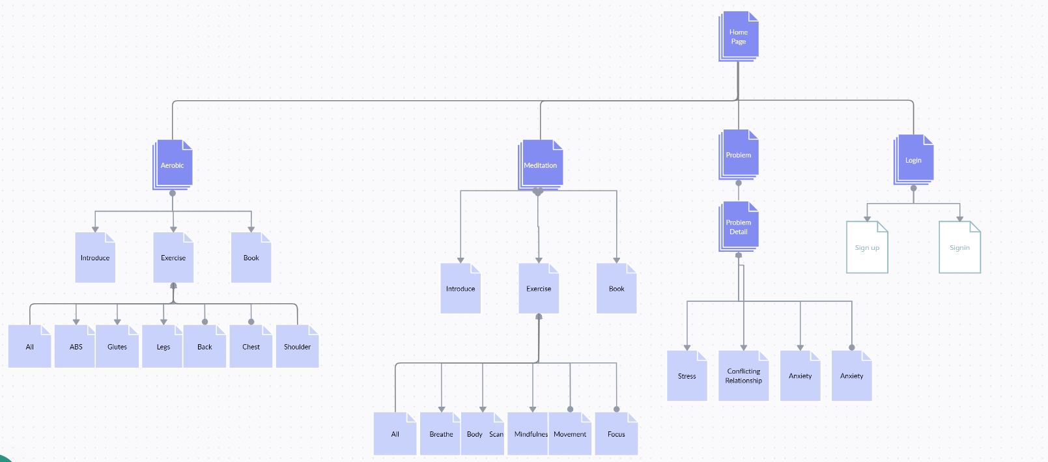

## Screen shots

### Homepage

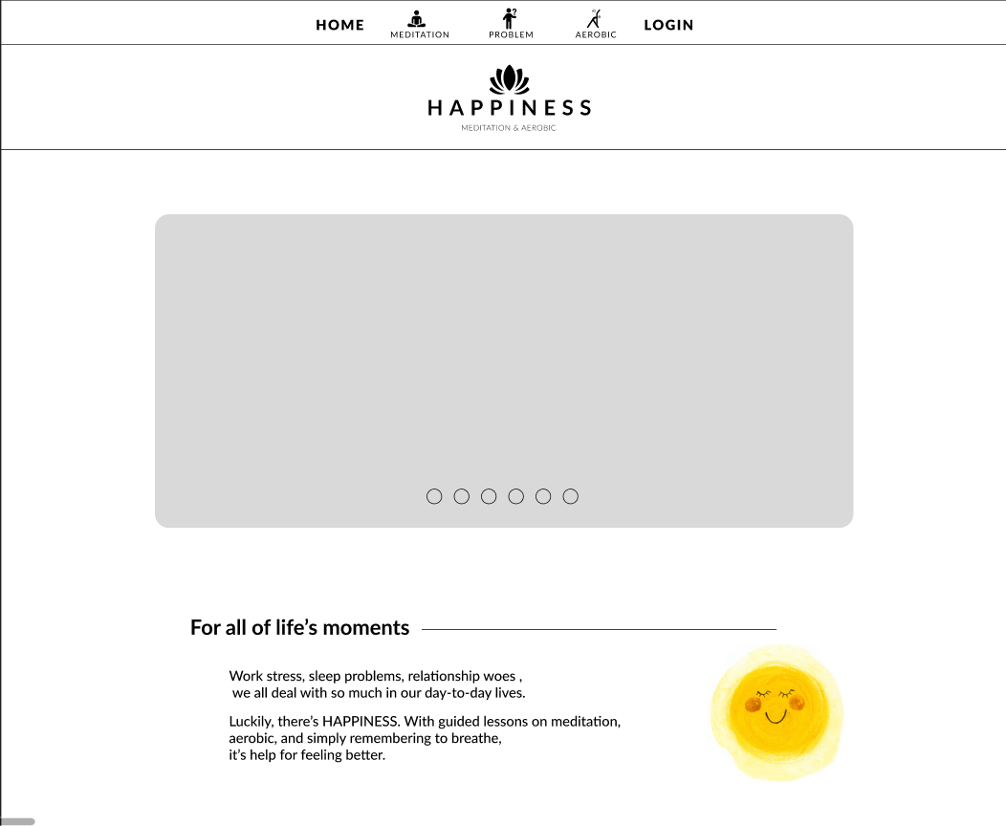

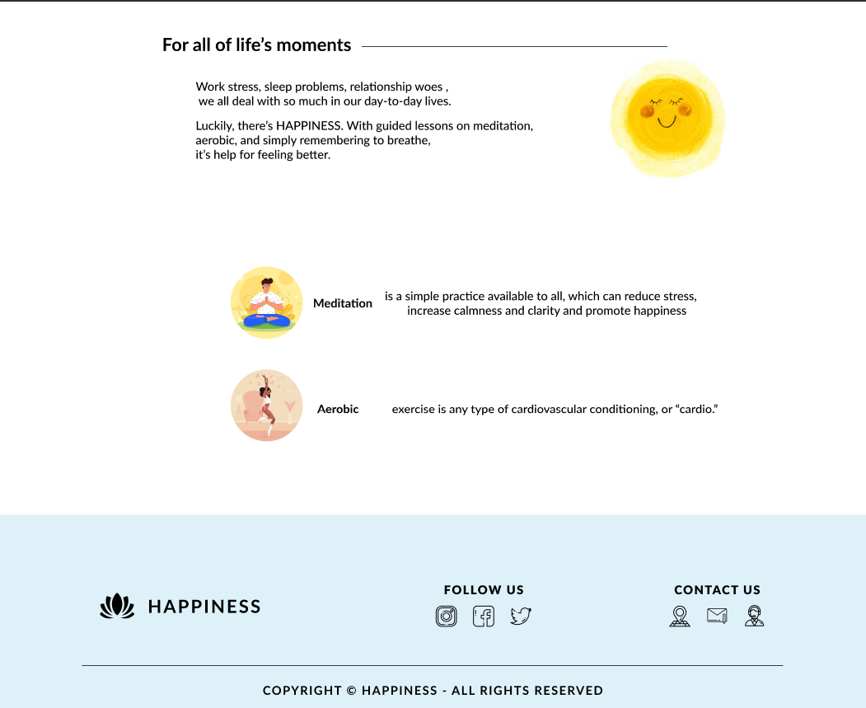

**Description:** This is a homepage of Happiness, the top of this page is a navigation bar, after that is a header. Homepage also show some pictures about Aerobic and Mediation. The footer of a homepage has 2 sections: follow and contact information.

### Sign in

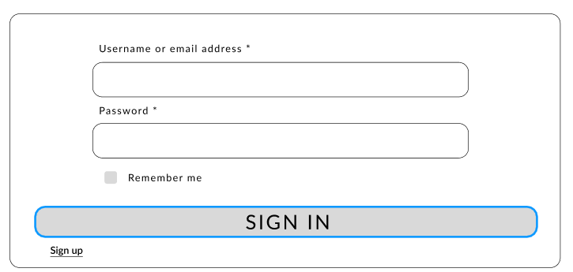

**Description:** When the user clicks on Login in the navigation bar, it leads to a sign in page. This form requires the user to enter an email address and a password. After clicking the login button, the user will be redirected to the homepage.

### Sign up

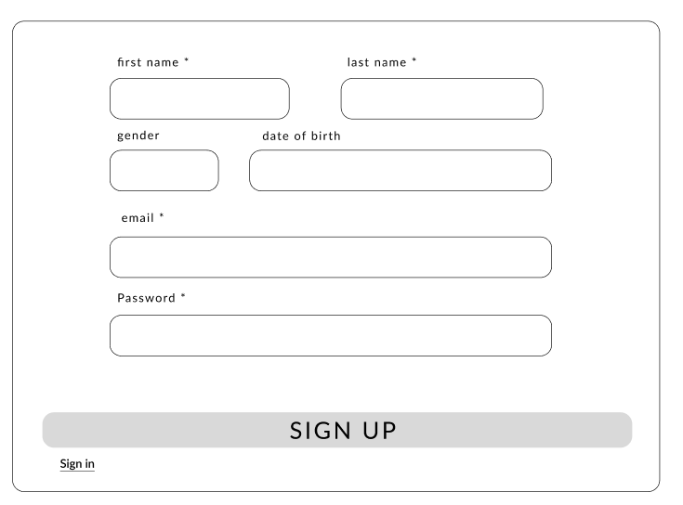

**Description:** If the user hasn’t created an account, he/she can click to Create new account in the sign in page and it will lead to this sign up page. This sign up form requires the user to enter 6 fields: first name, last name,gender,date of birth, email and password. After clicking the sign up button the user will be redirected to the homepage.

### Aerobic

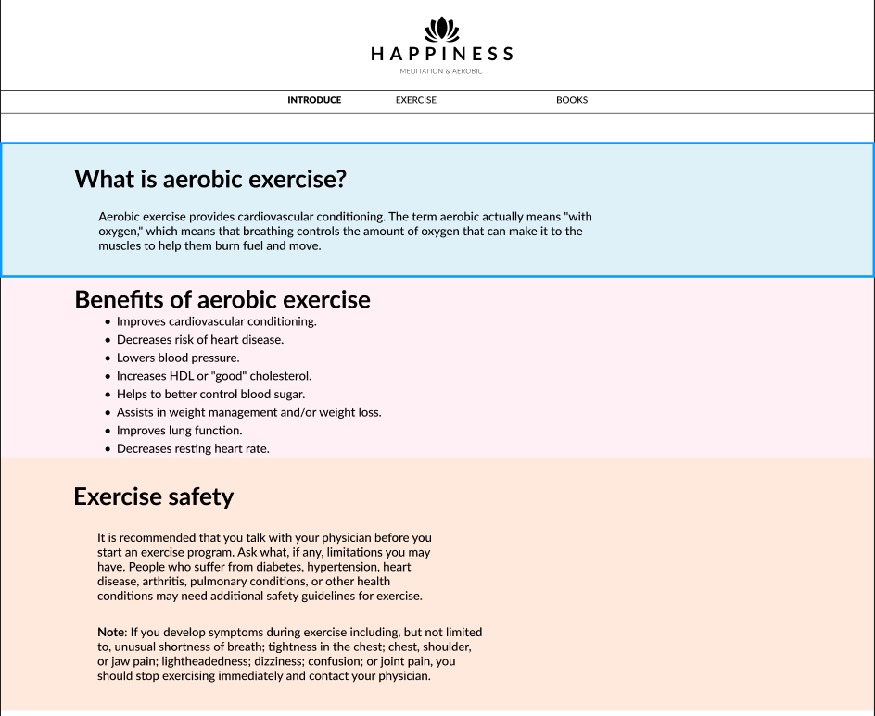

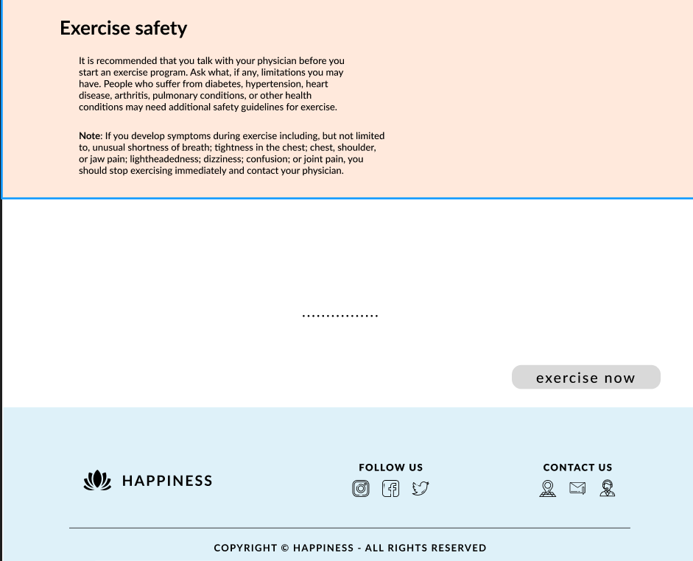

**Description:** When the user clicks on the Aerobic tag in navigation, it will lead to this page.This page have a navigation include introduce, exercise and book. The introduce tag show some info about aerobic. When user click on Exercise now button , it will lead to Exercise page.

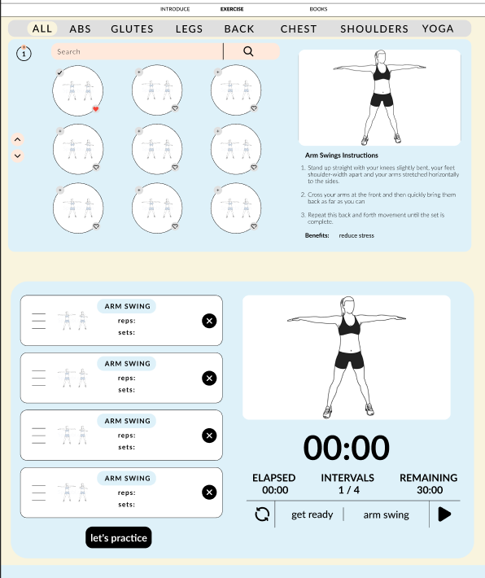

**Description:** When the user clicks on the Exercise tag in navigation(or click on Exercise now button at Introduce page), it will lead to this page.This page have a navigation link to exercise modules.The main part show info of each exercise. Search button can help find which exercise you want to practice. Moving picture with clock and some helpful button can help user practice easier.

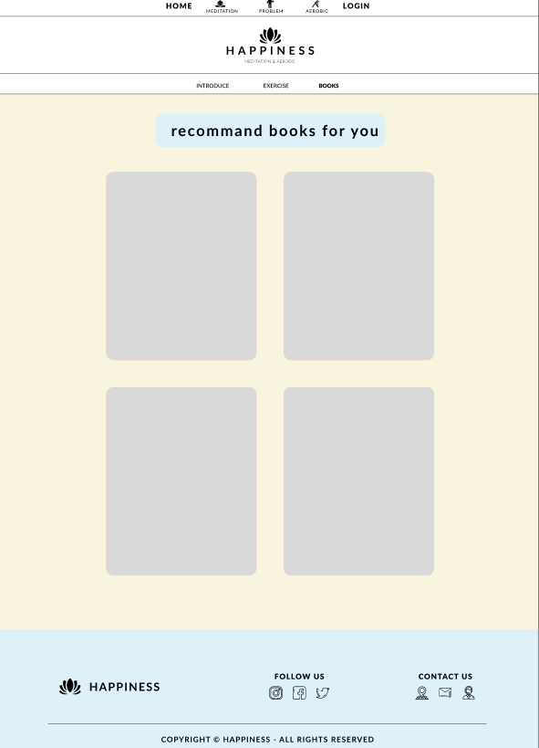

**Description:** When the user clicks on the Book tag in navigation, it will lead to this page. This page will show some recommend book that’s usefull in Aerobic practice.

### Meditation

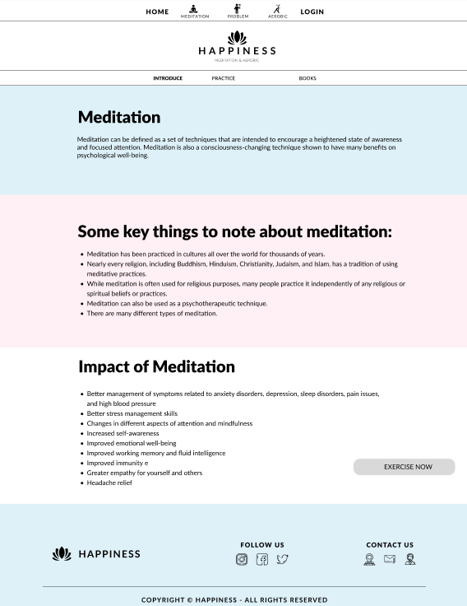

**Description:** When the user clicks on the Meditation tag in navigation, it will lead to this page.This page have a navigation include introduce, exercise and book. The introduce tag show some info about Meditation.When user click on Exercise now button , it will lead to Exercise page.

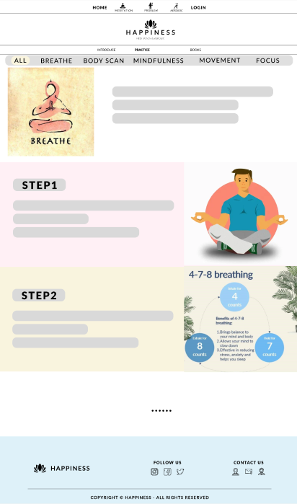

**Description:** When the user clicks on the Exercise tag in navigation(or click on Exercise now button at Introduce page), it will lead to this page.This page have a navigation link to exercise modules.The main part show info of each exercise.

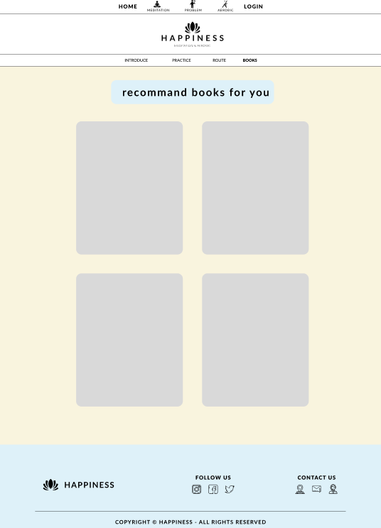

**Description:** Same with Aerobic page , this page show some recommend book about meditation for user.

### Problem

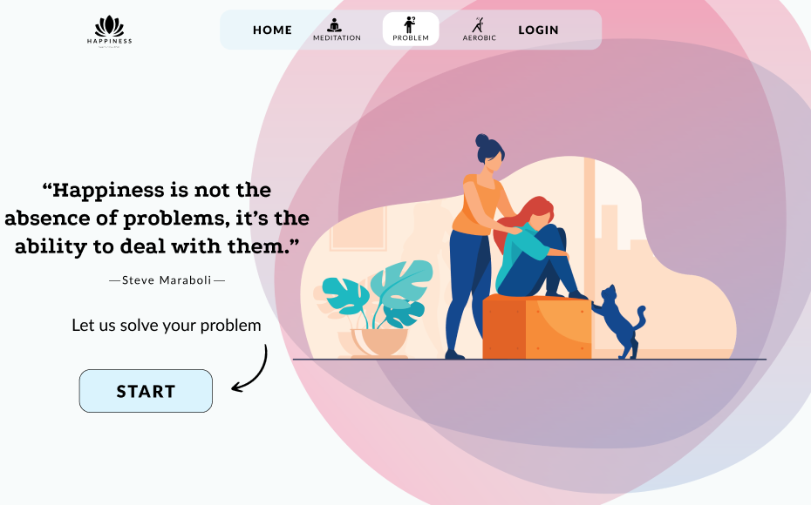

**Description:** When the user clicks on the Problem tag in navigationit will lead to this page.This page have Start button ,it will lead to another page when click on this button.

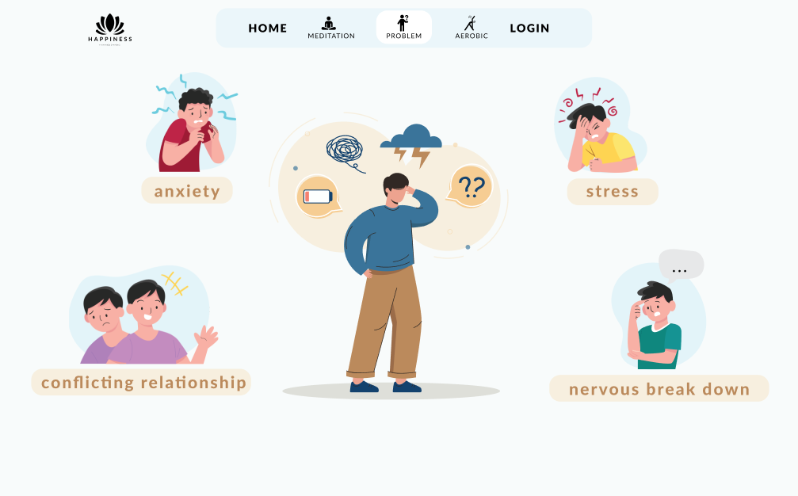

**Description:** This page showed when user clicked on Start button.This page have 4 option include problems that’s user want to slove. It will find solution to solving problem that user have.

## Task Sheet

|  |  |  |  |  |  |  |
| --- | --- | --- | --- | --- | --- | --- |
| **Project Ref No.** | **Project Title – Ask Me Mobile** | **Activity Plan Prepared by** | **Date of preparation of Activity Plan** | | | |
| **Task** | **Actual Start Date** | **Actual Days** | **Teammate Names** | **Status** |
| Brainstorming ideas for layouts and Project Object | | Phat, Khai, Hien | 20/10/2022 | 7days | Phat, Khai, Hien | Completed |
| Draw site maps and architecture design | | Phat,Khai | 24/10/2022 | 3 days | Phat,Khai | Completed |
| Wire framing general page layout | | Phat | 27/10/2022 | 3 days | Phat | Completed |
| Collect static assets (pictures, mp4, documentation,…) | | Hien,Khai | 24/10/2022 | 6days | Hien,Khai | Completed |

# REVIEW 2

# WEBSITE USER INTERFACE

### Homepage

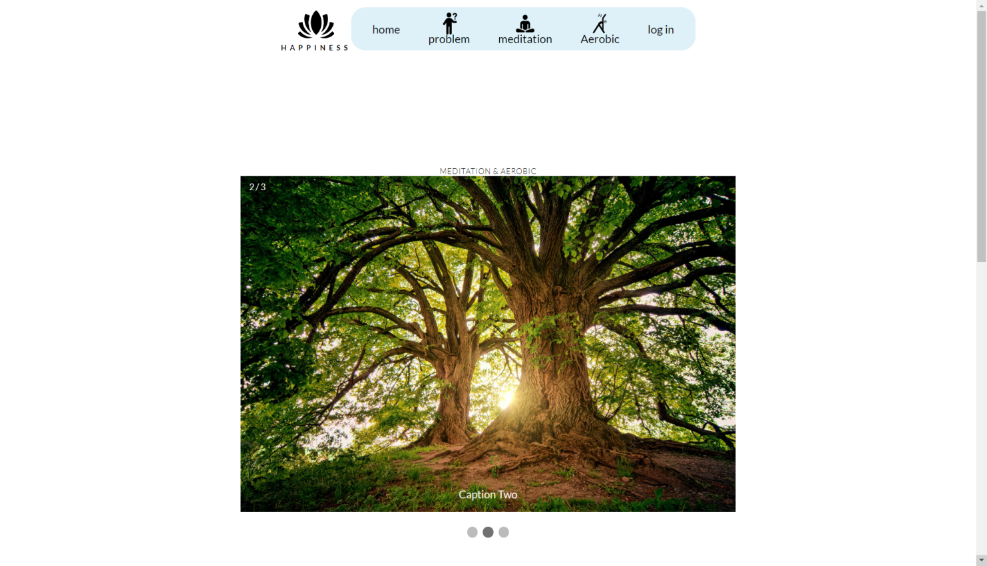

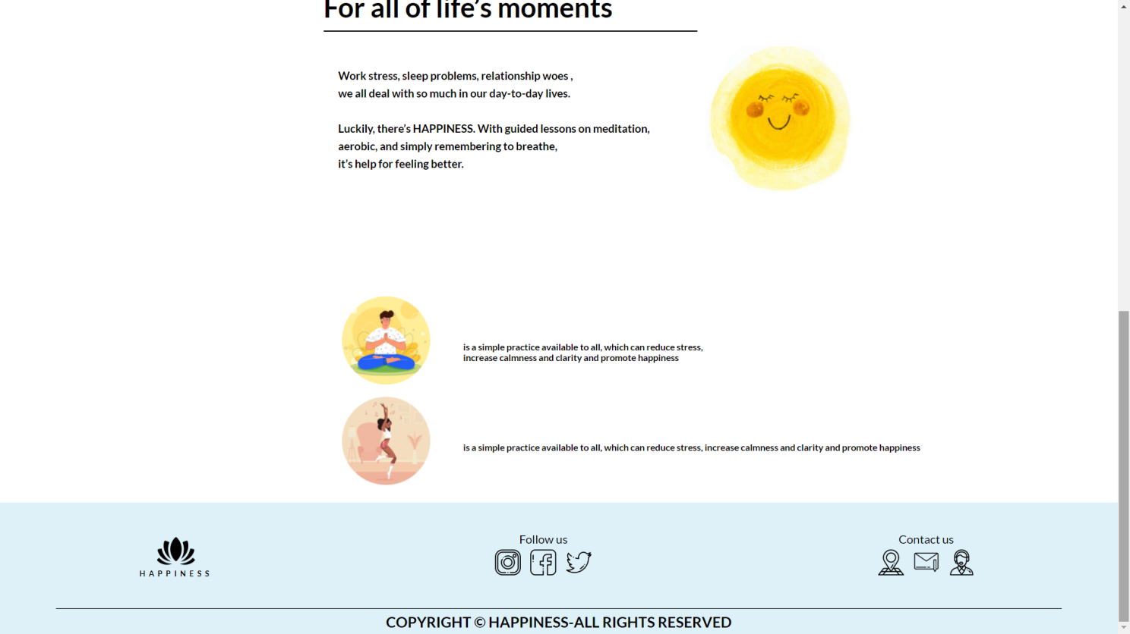

### Sign in

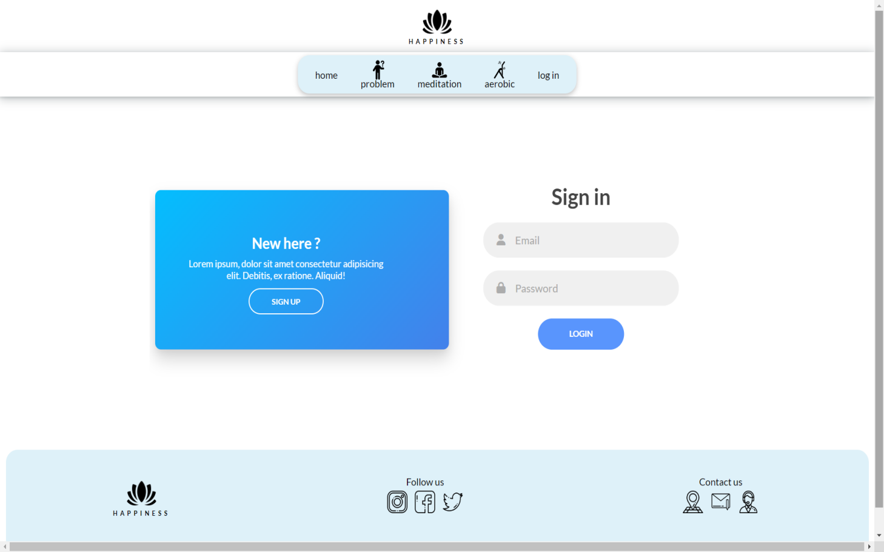

### Sign up

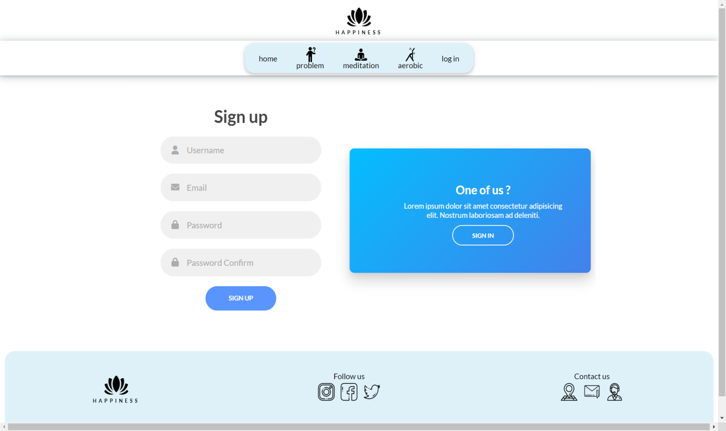

### Problem

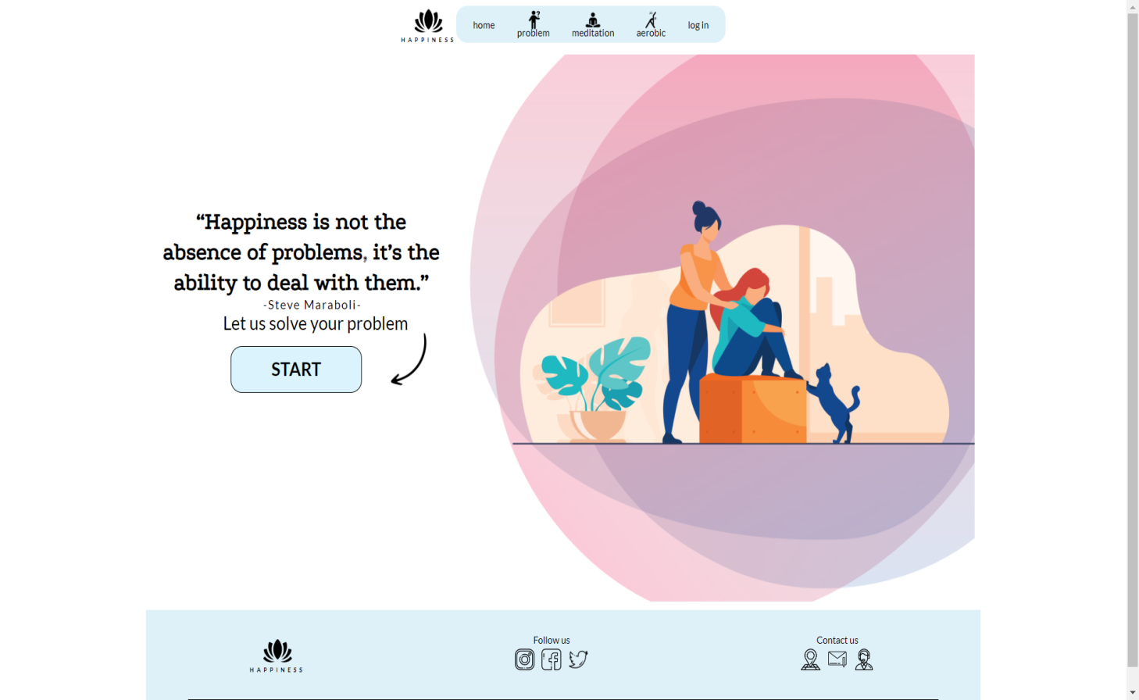

**Description:** After clicking the START card. The page will show the problems we are facing.

### How do you feel ?

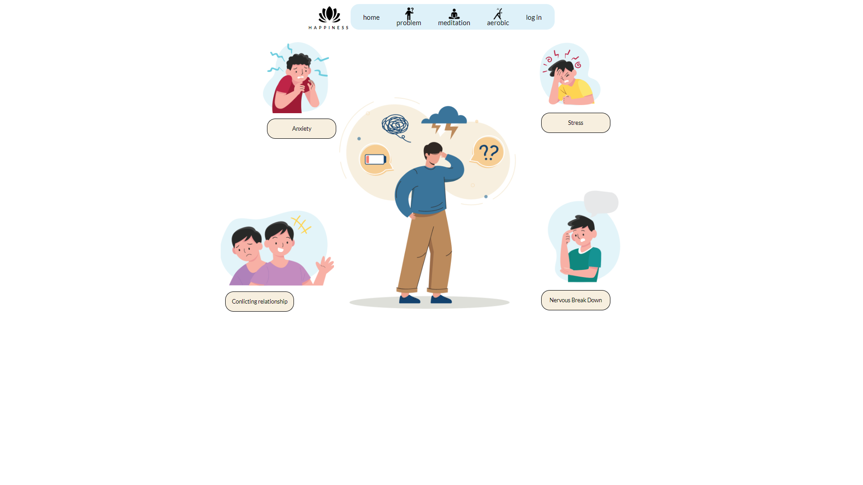

**Description**: There are 4 problem items: Stress, Axiety, Conlicting Relationship, Nervous Break Down and we will choose one.

### Anxiety

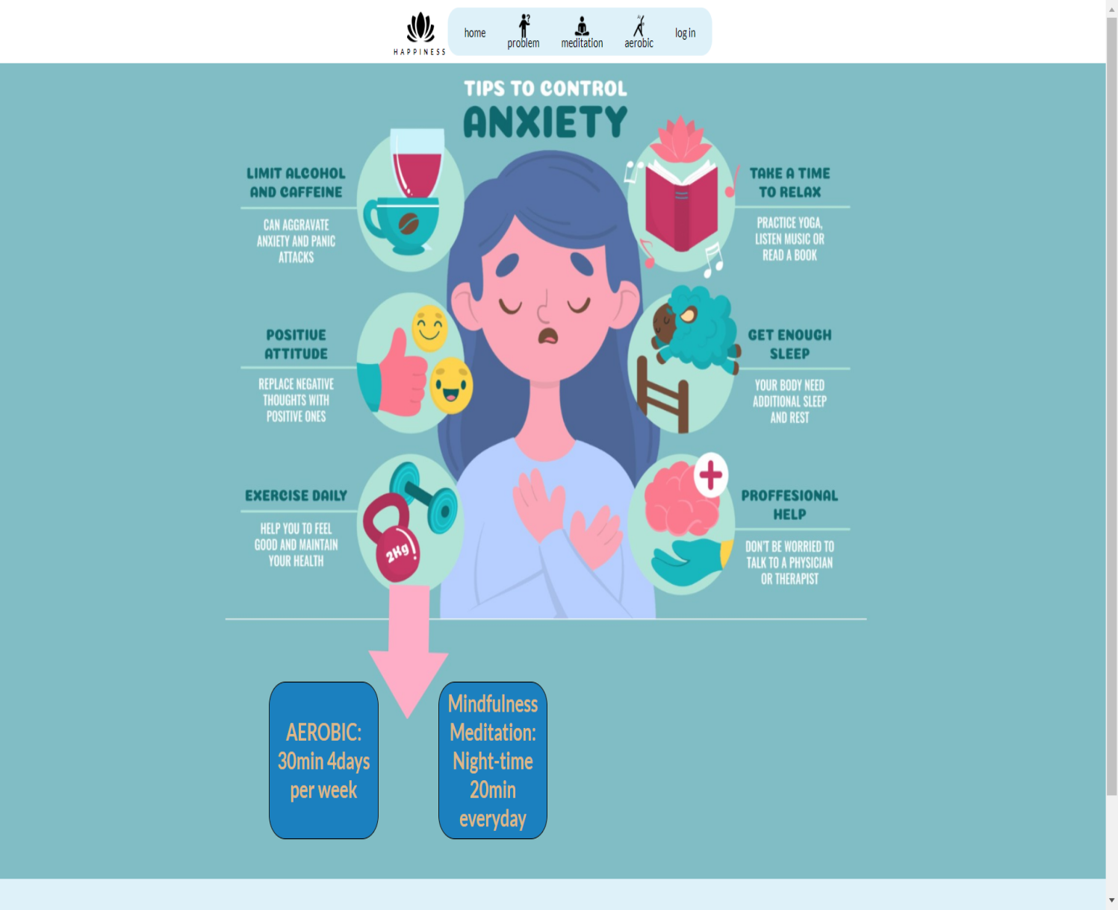

**Description**: We can choose the Exercise section and the Mindfulness section to improve the problem.

### Stress

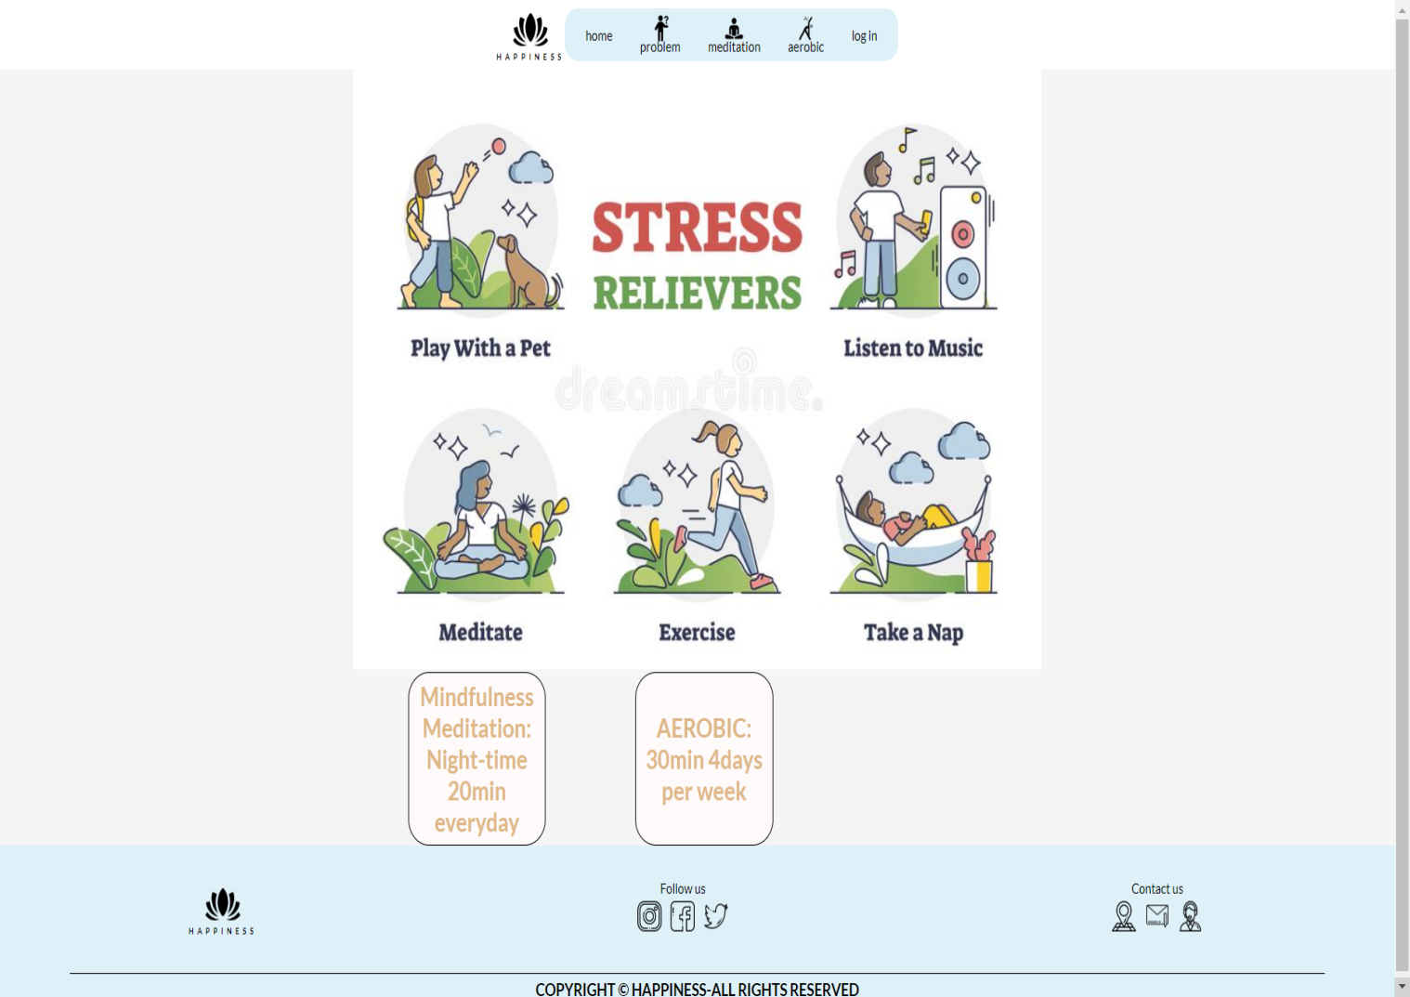

**Description**: We can choose the Exercise section and the Mindfulness section to improve the problem.

### Conlicting relationship

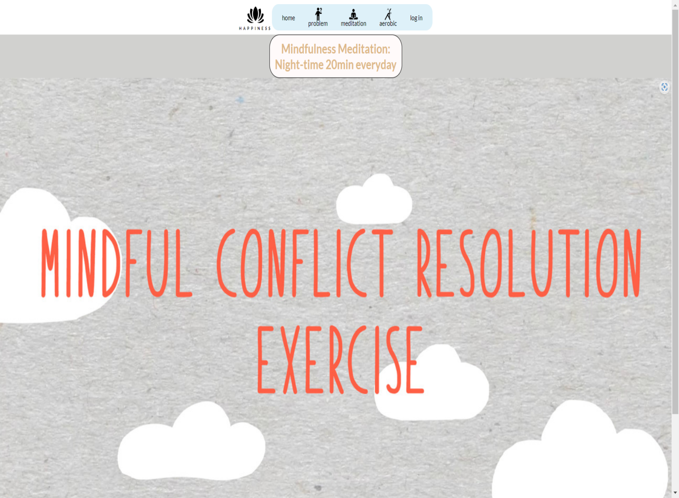

### Nervous Break Down

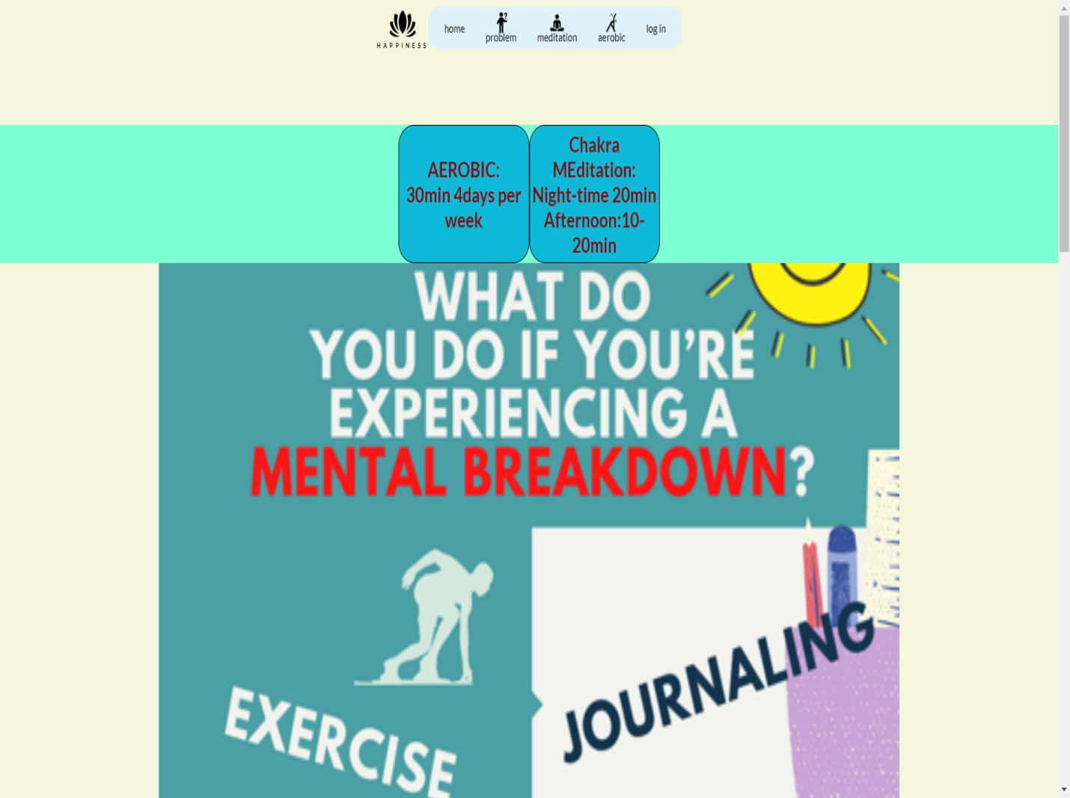



### Meditation (Introduce)

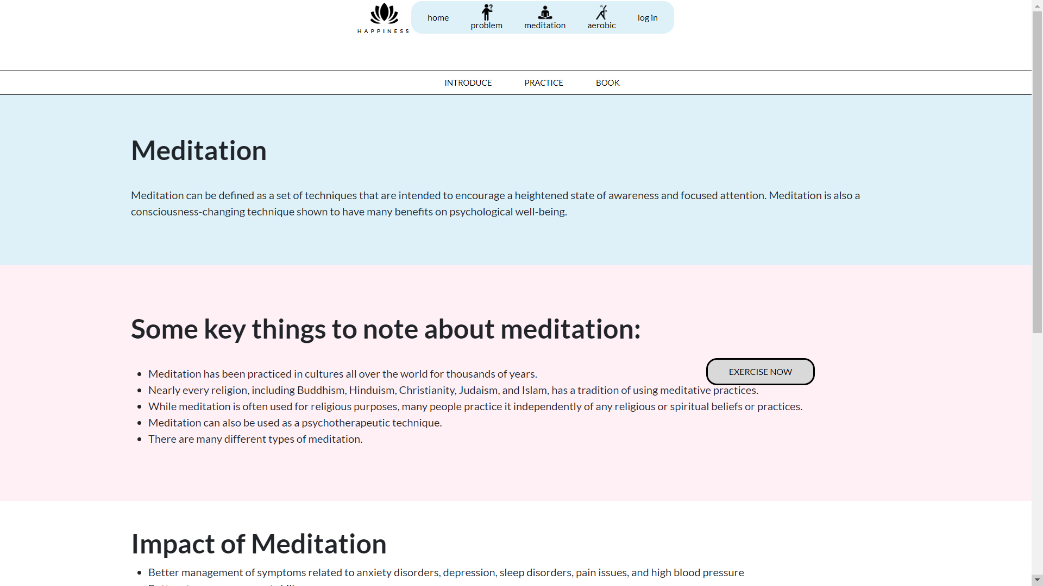

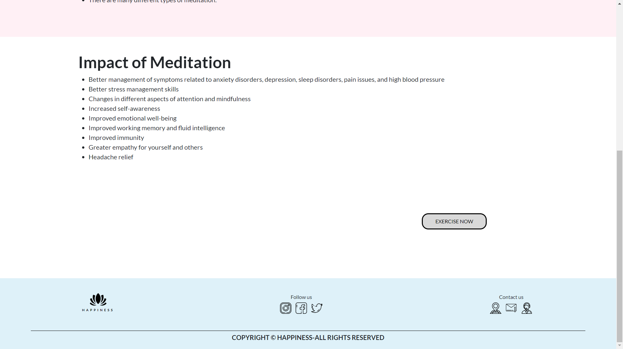

### Meditation(Practice)

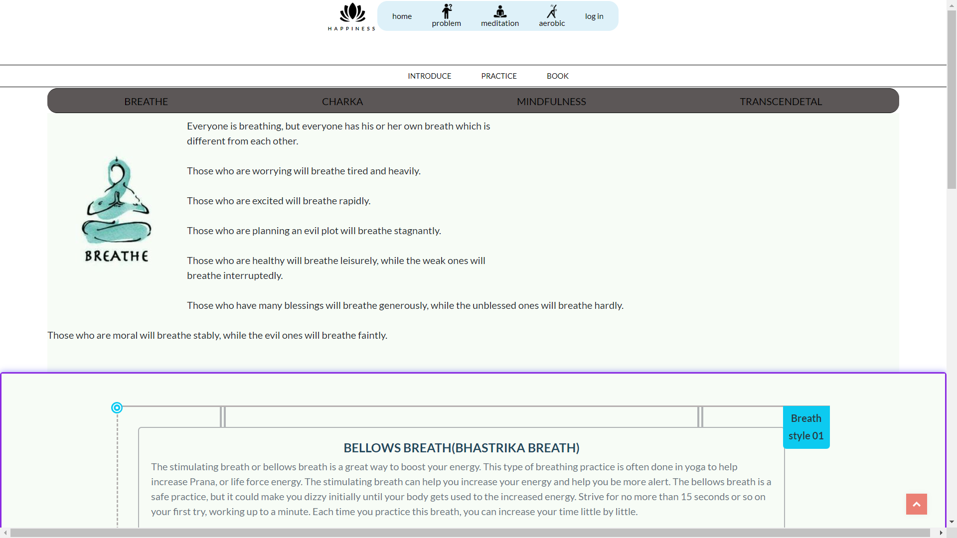

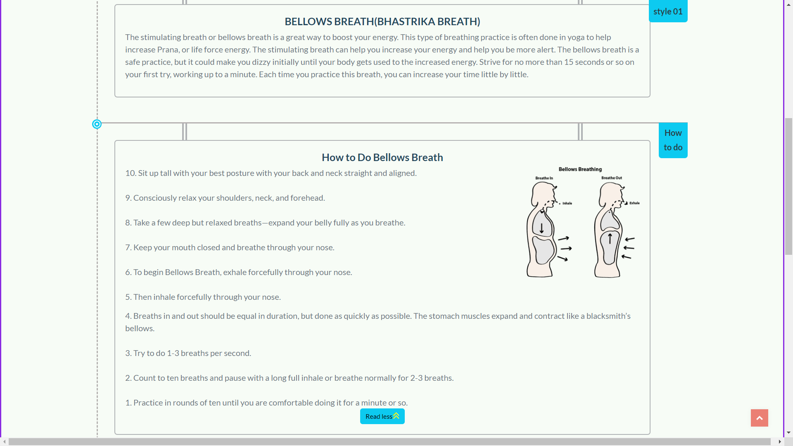

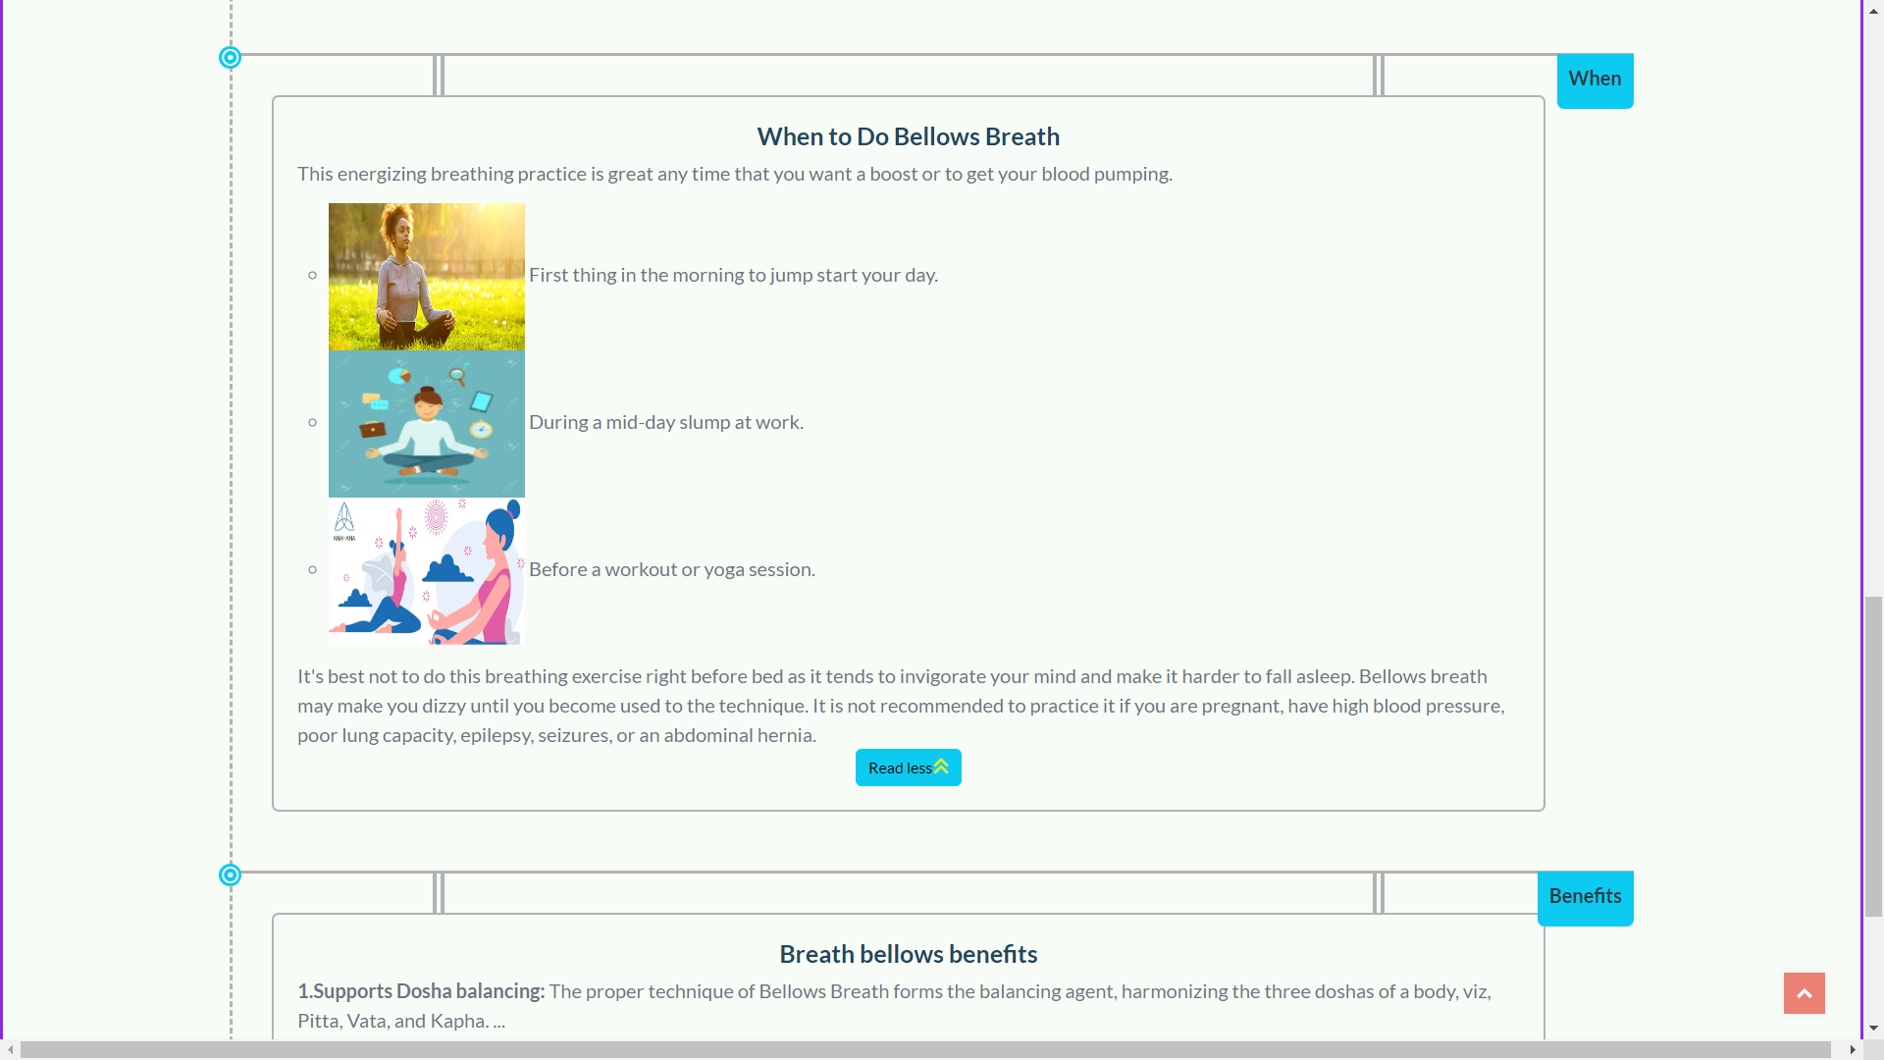

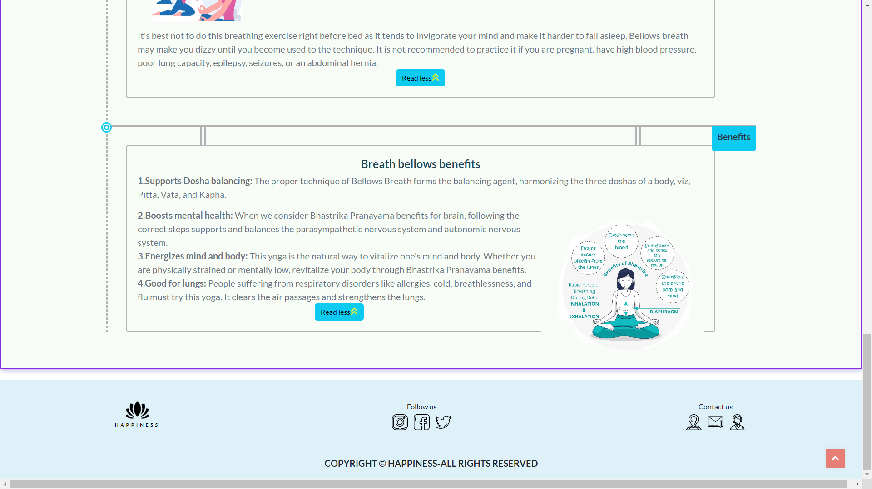

### Practice(Chakra)

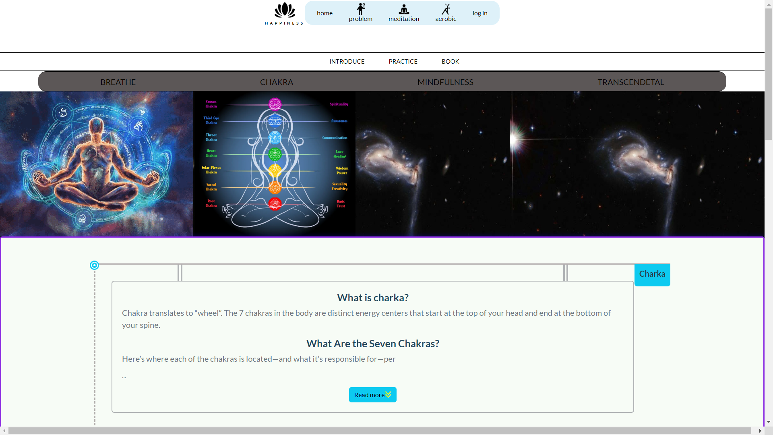

Click read more Chakra

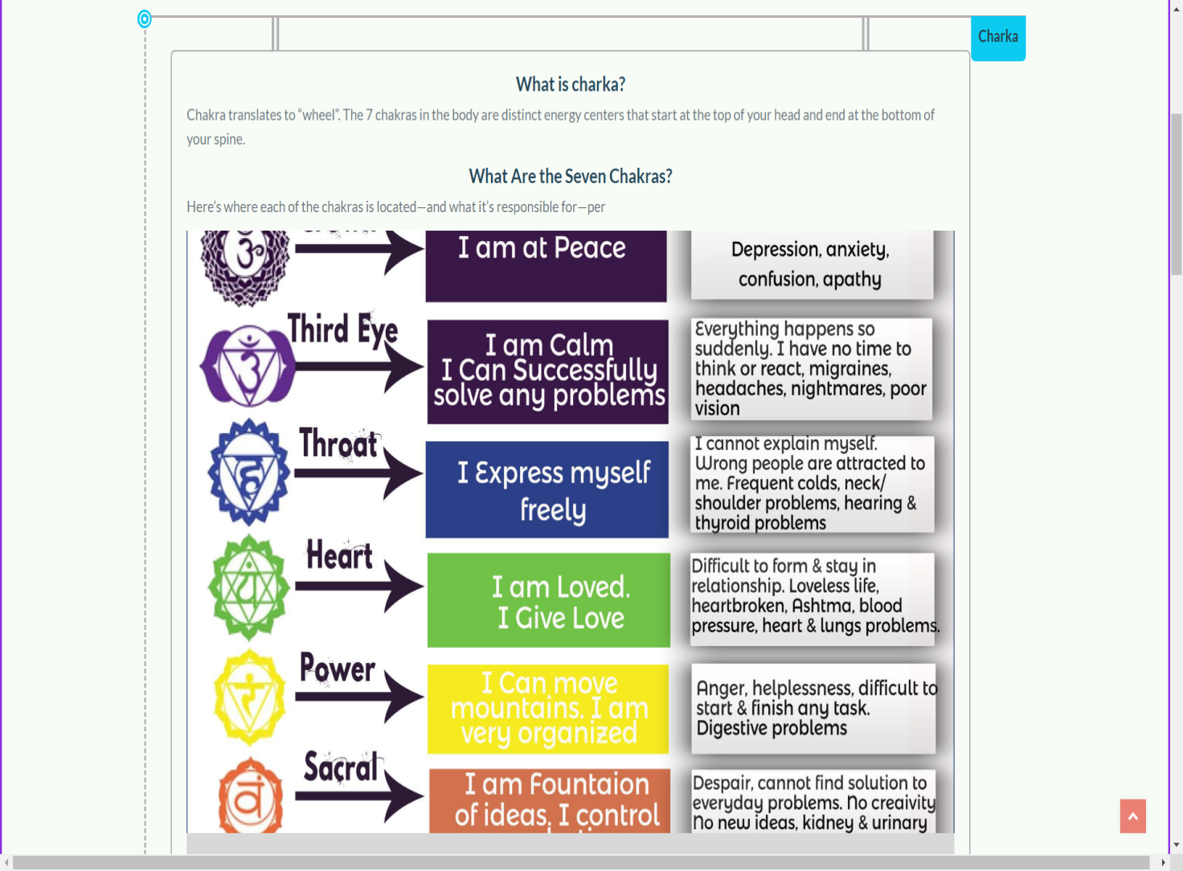

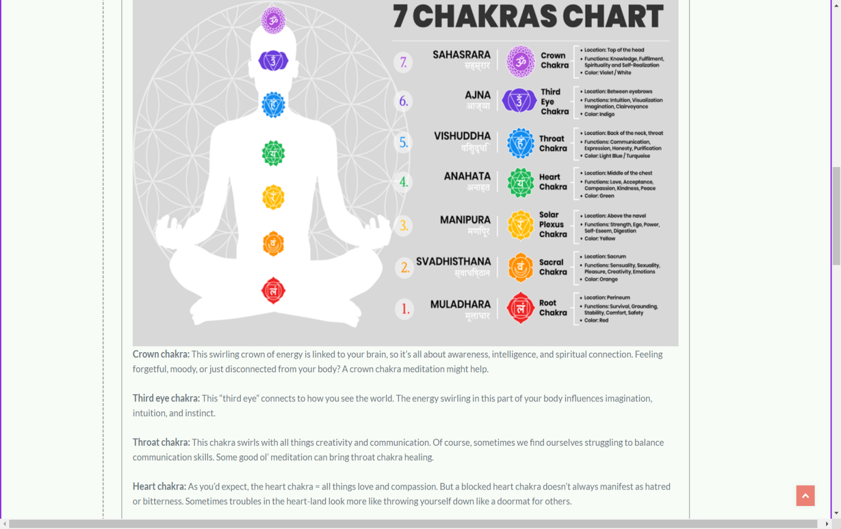

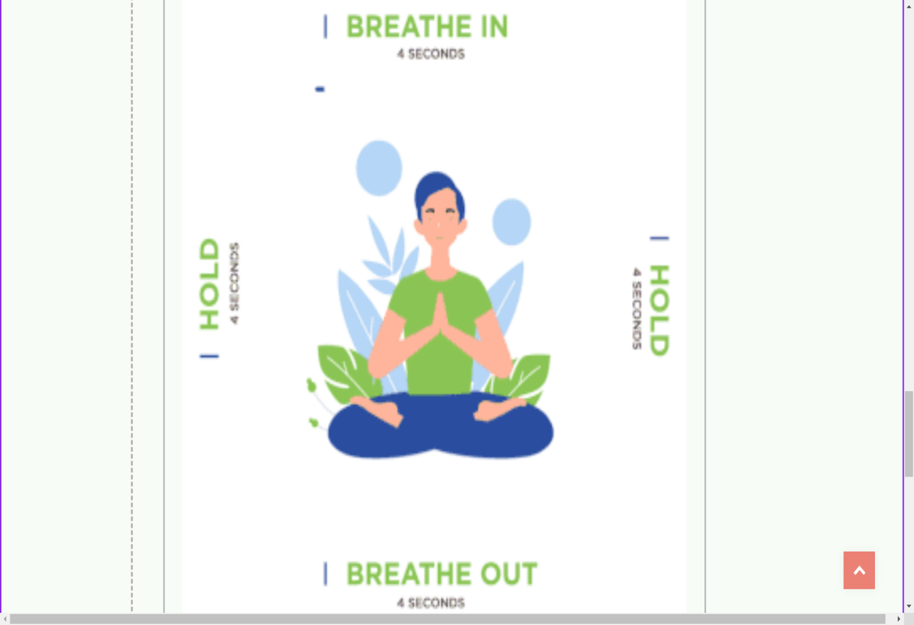

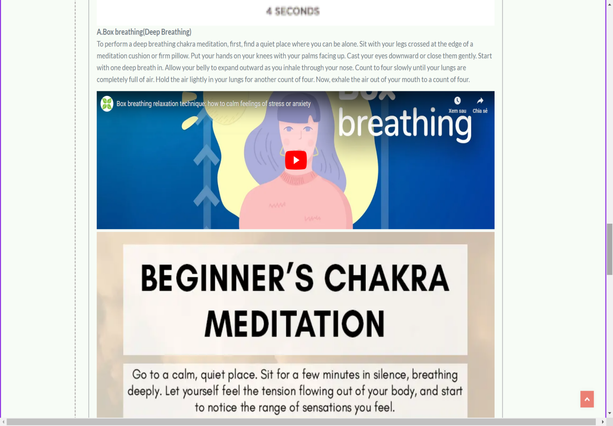

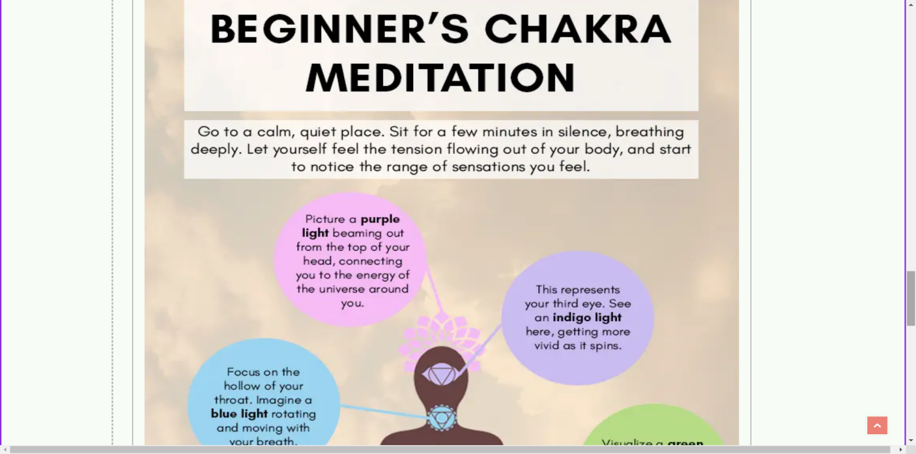

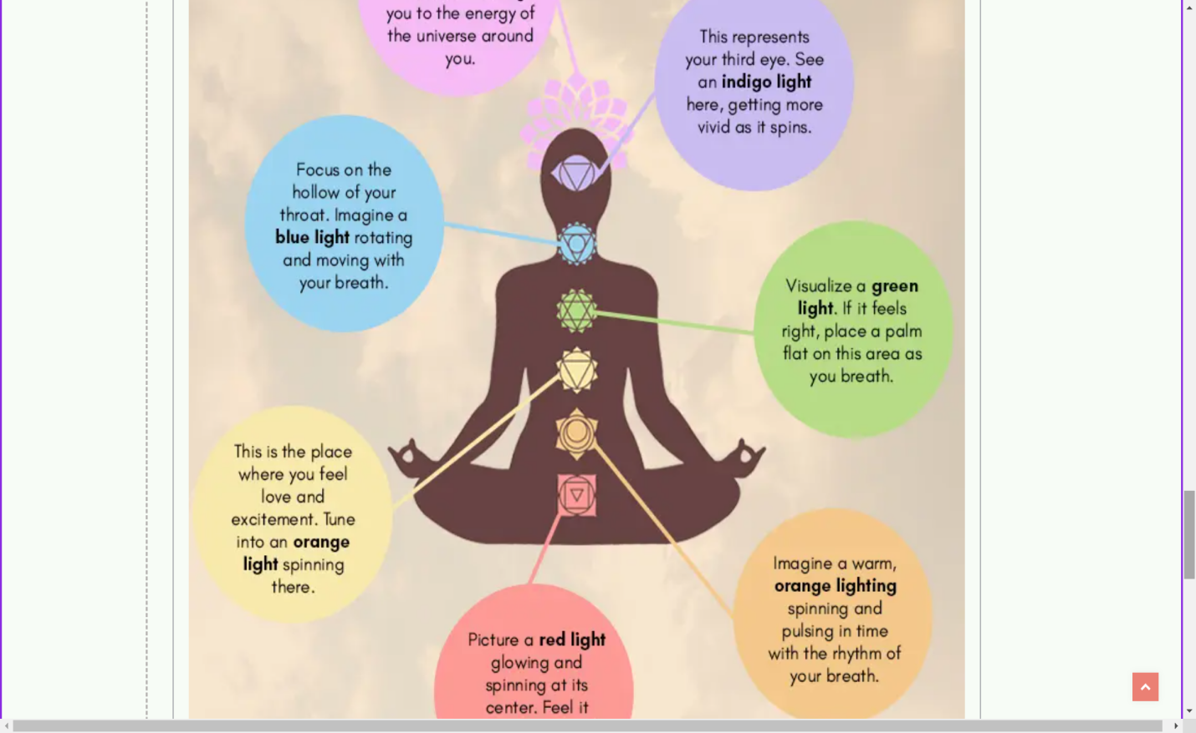

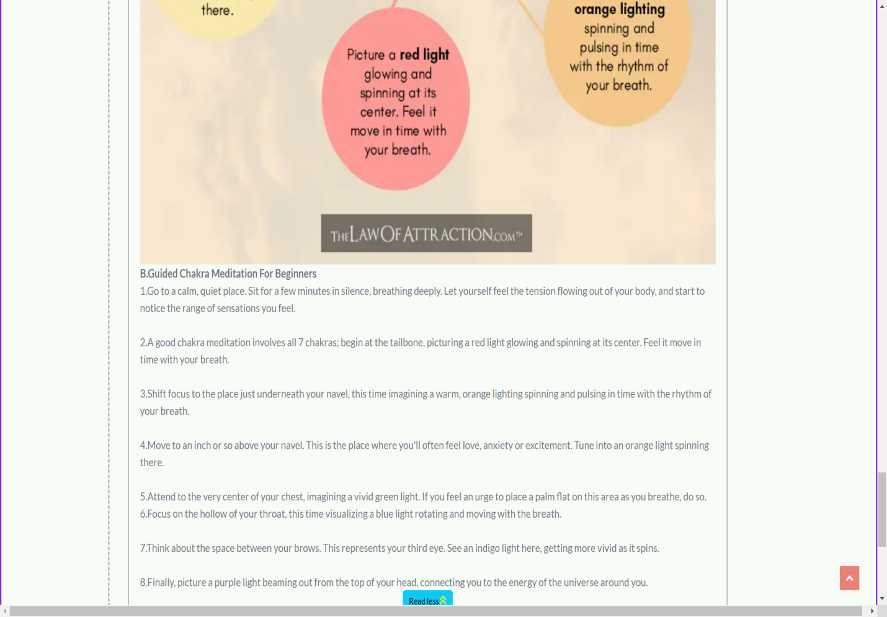

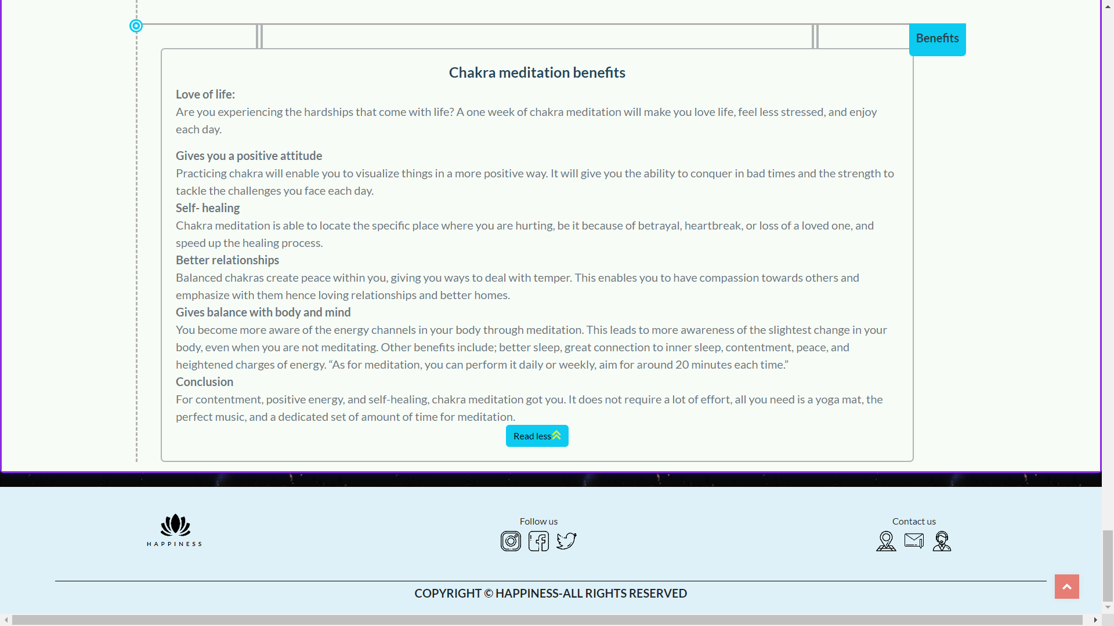

### Practice(Mindfulness)

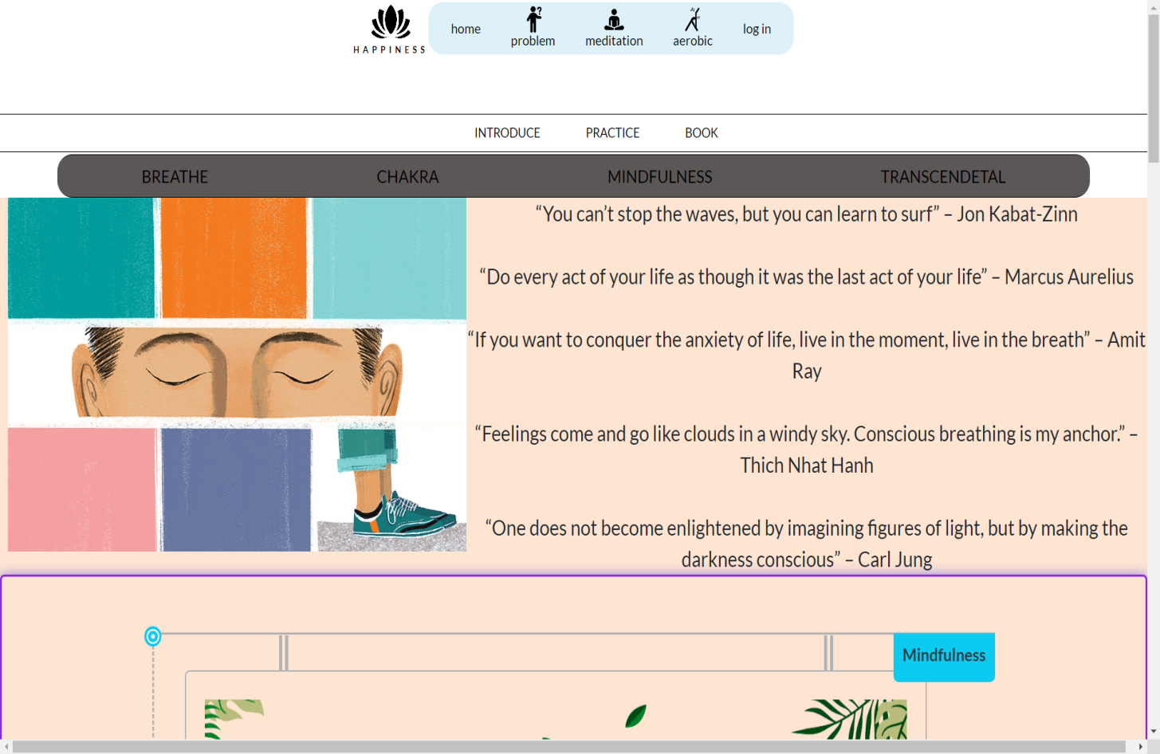

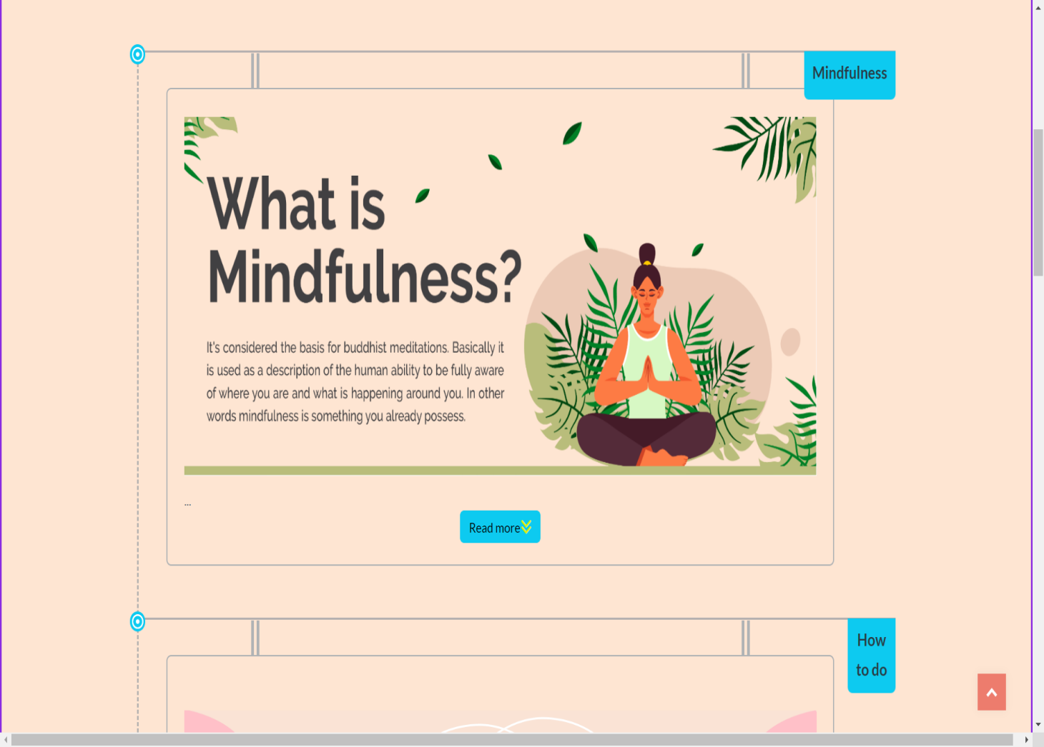

Read more

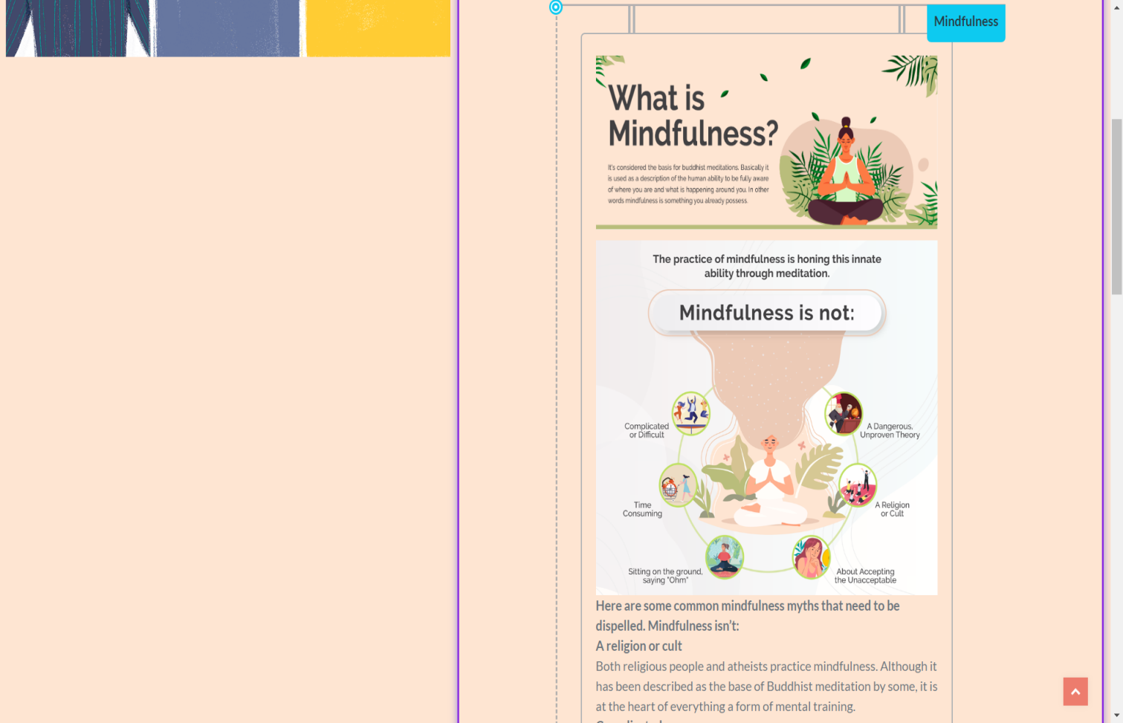

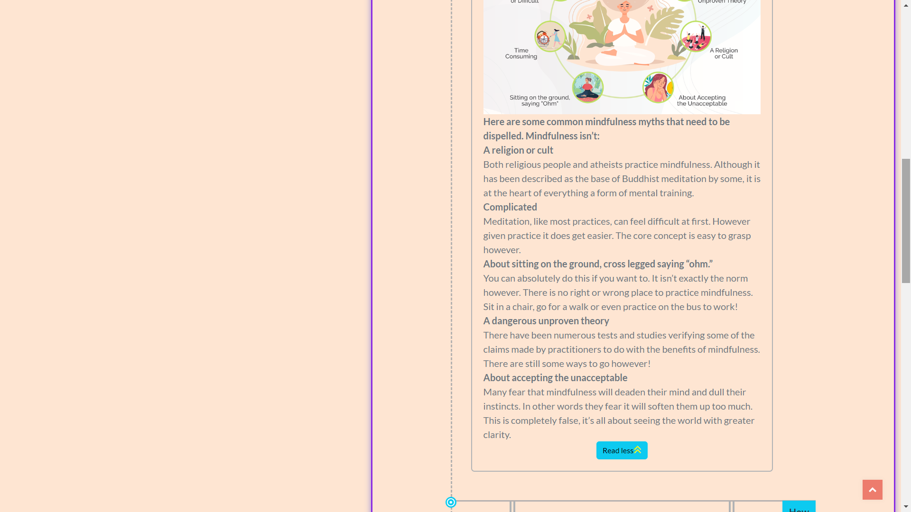

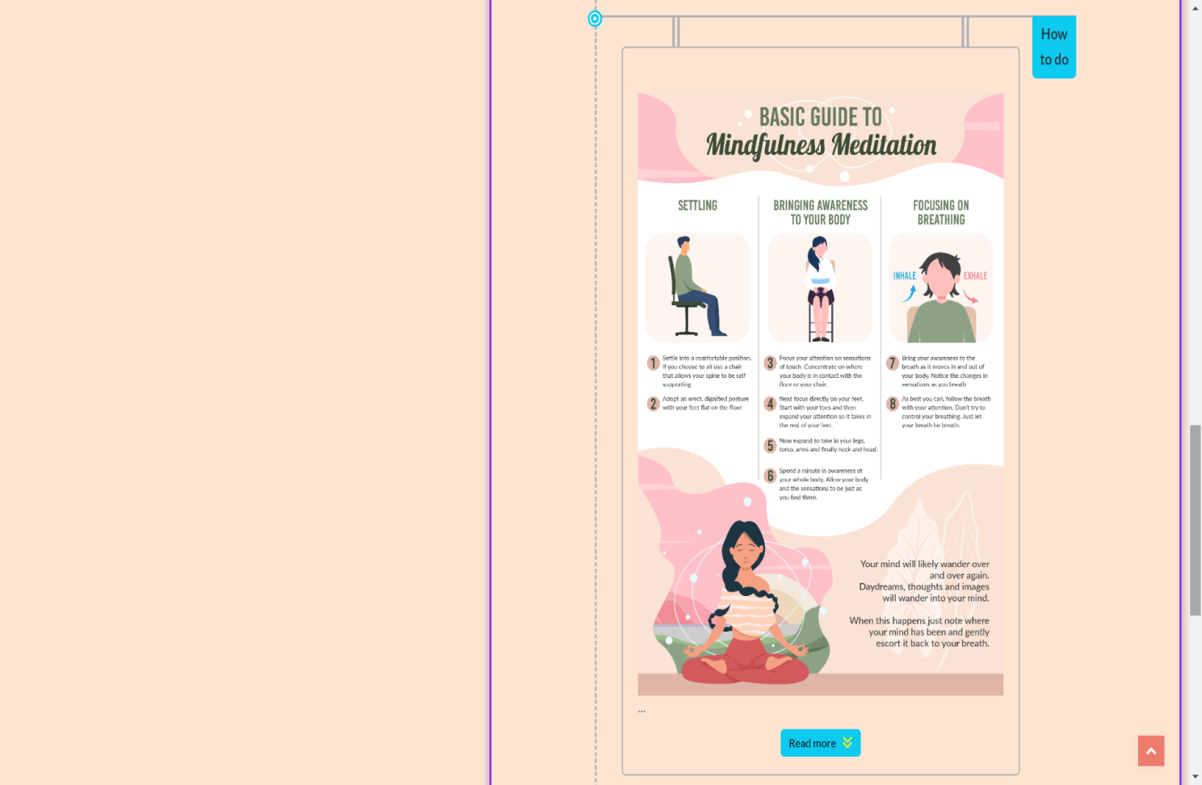

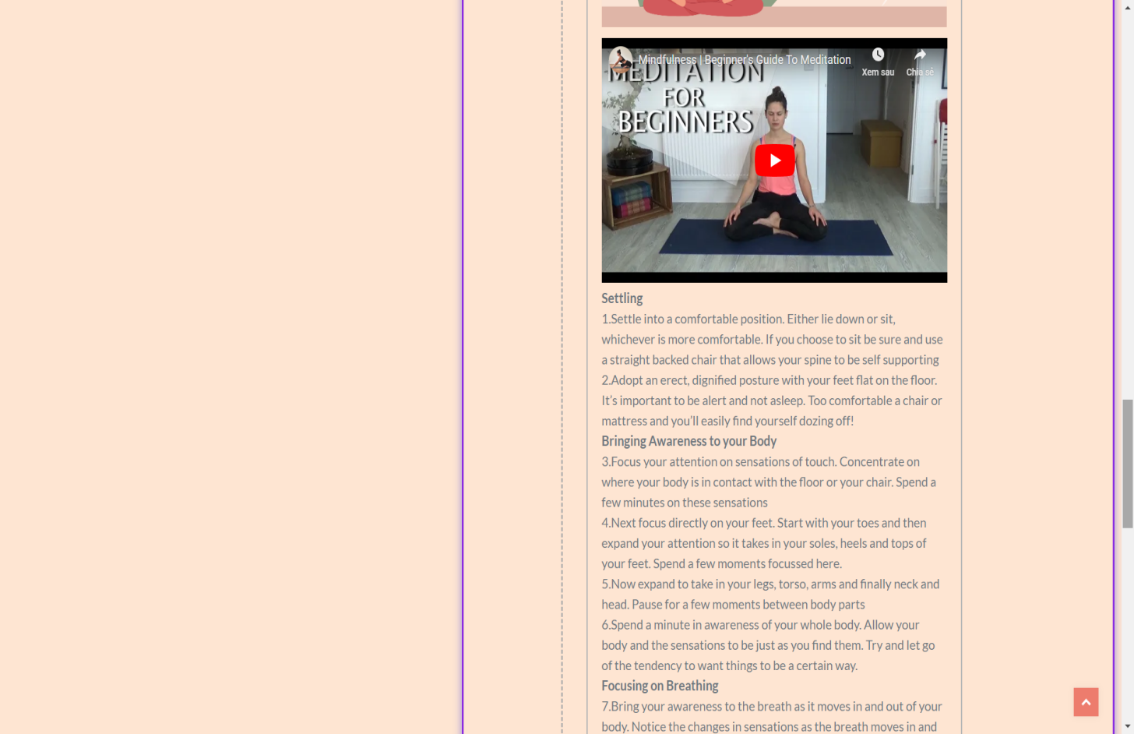

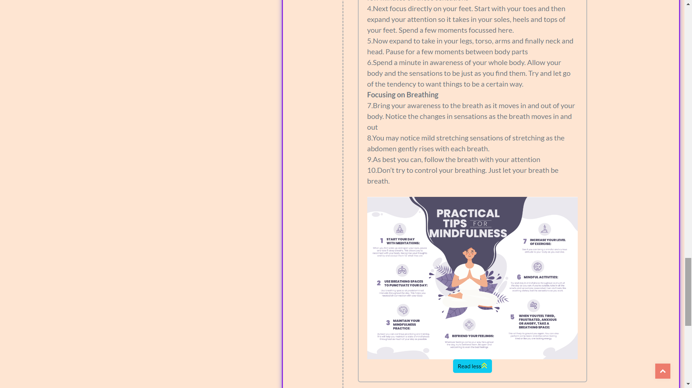

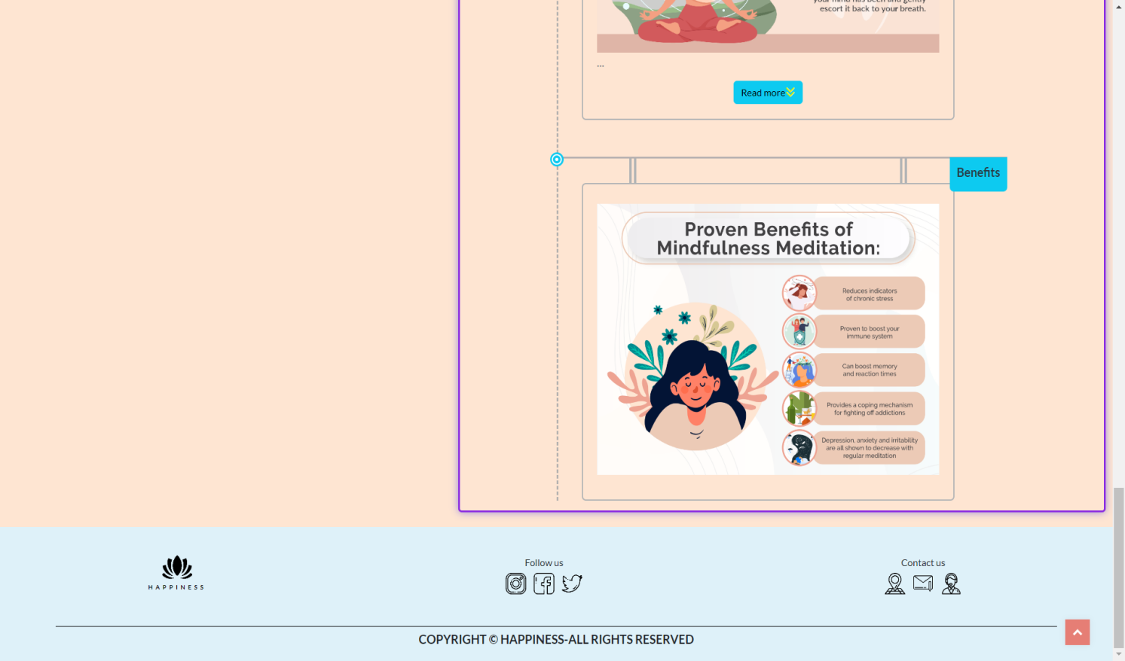

### Practice(Transcendetal)

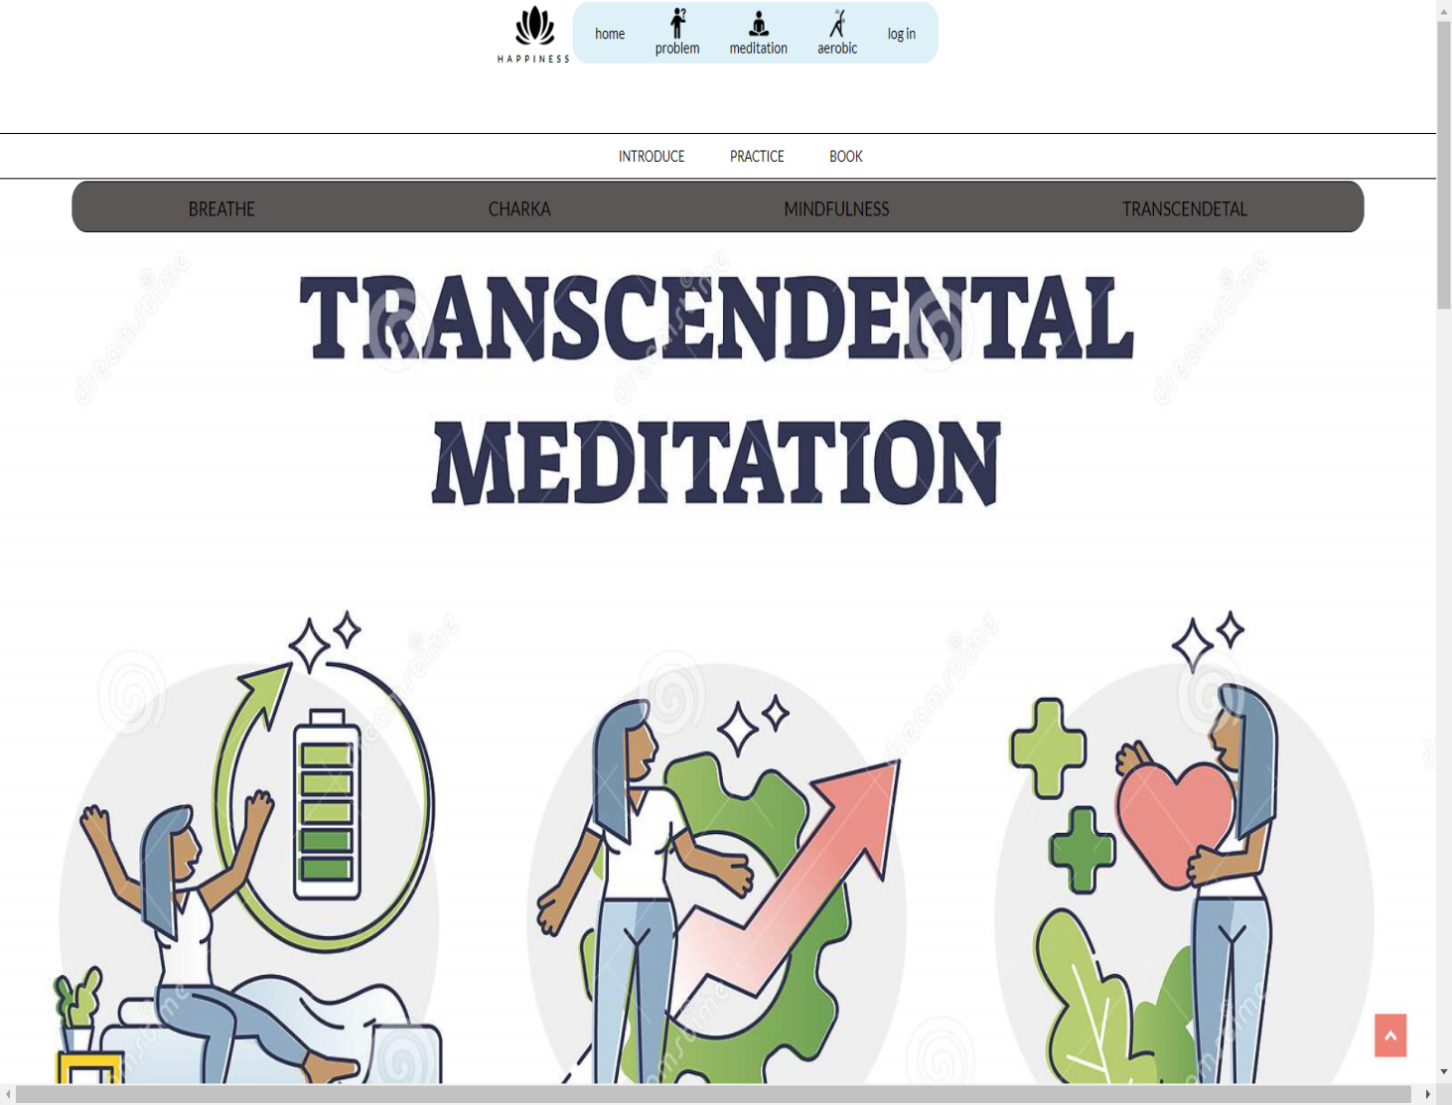

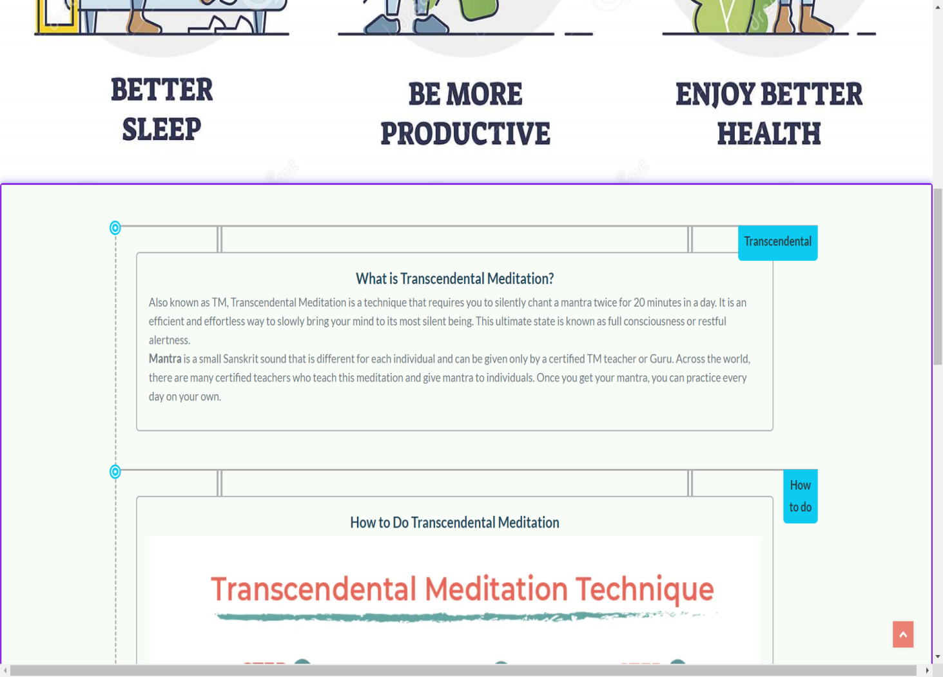

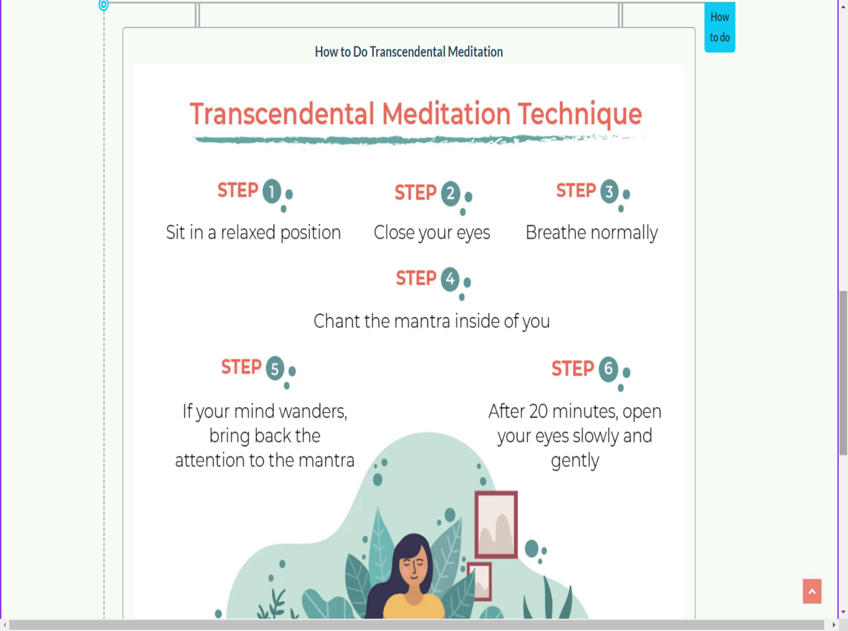

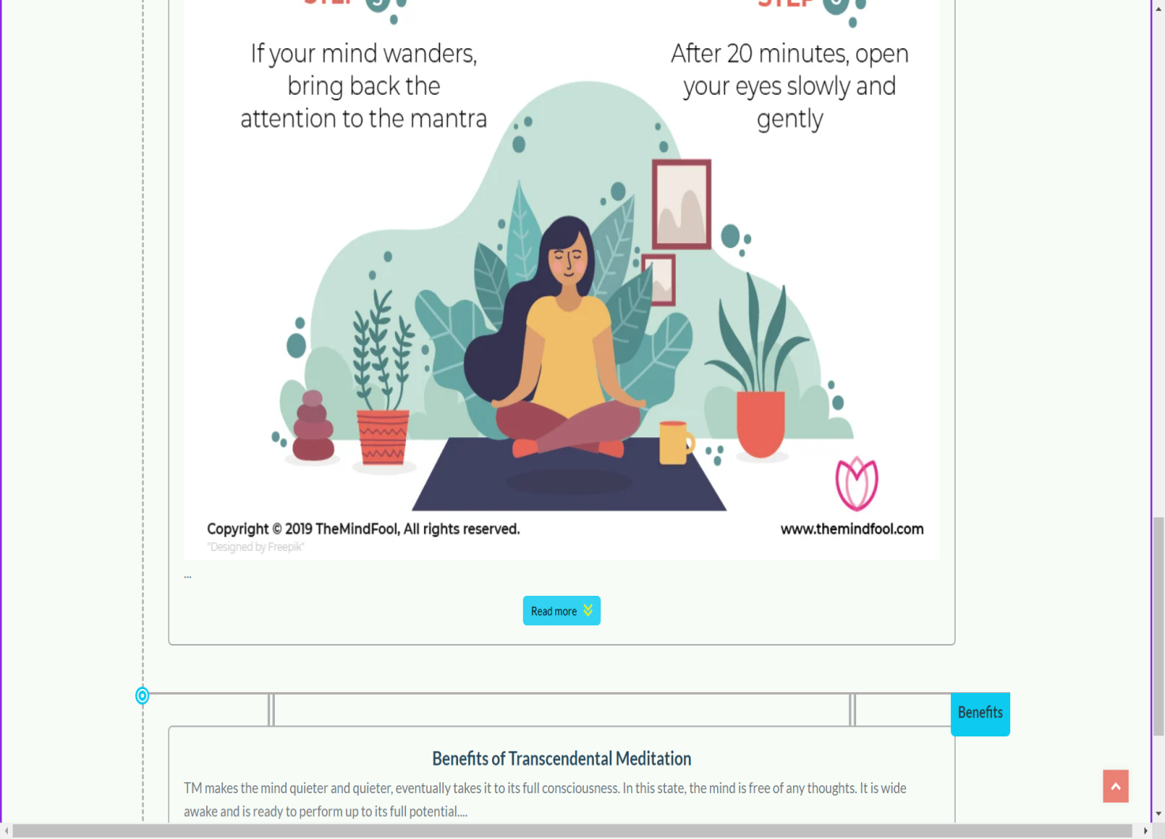

Read more

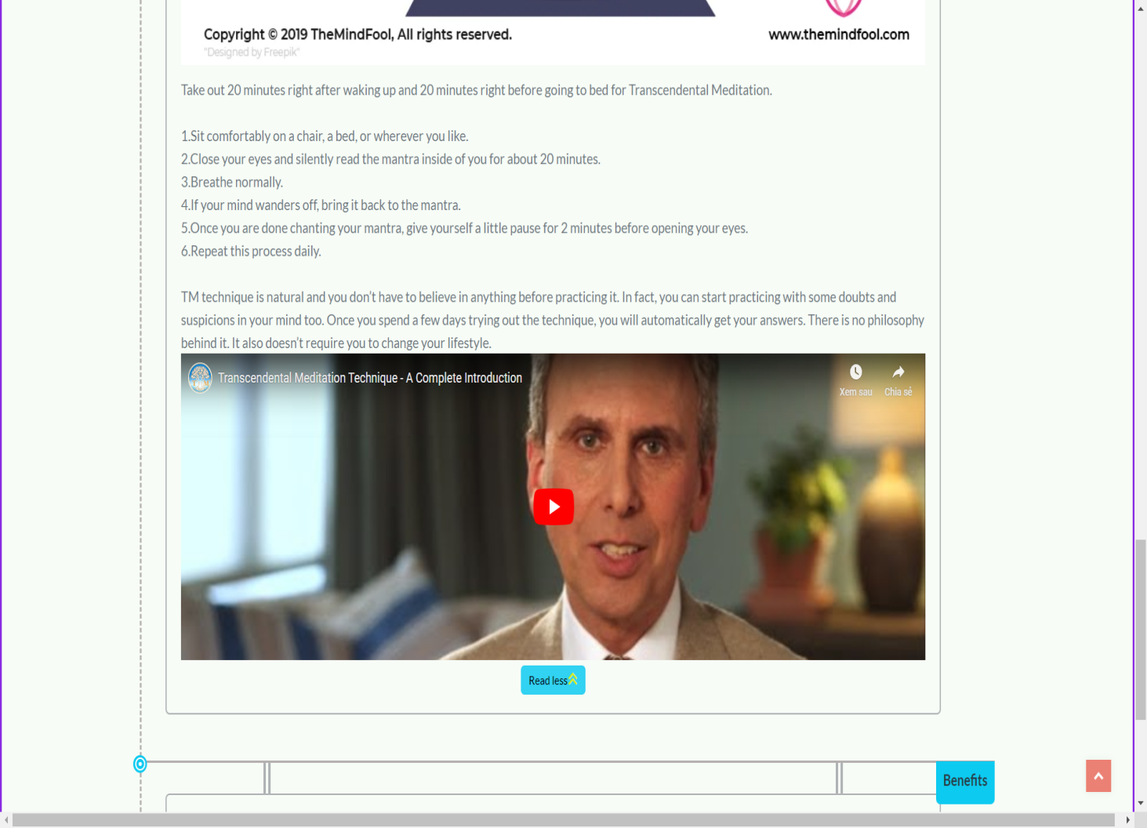

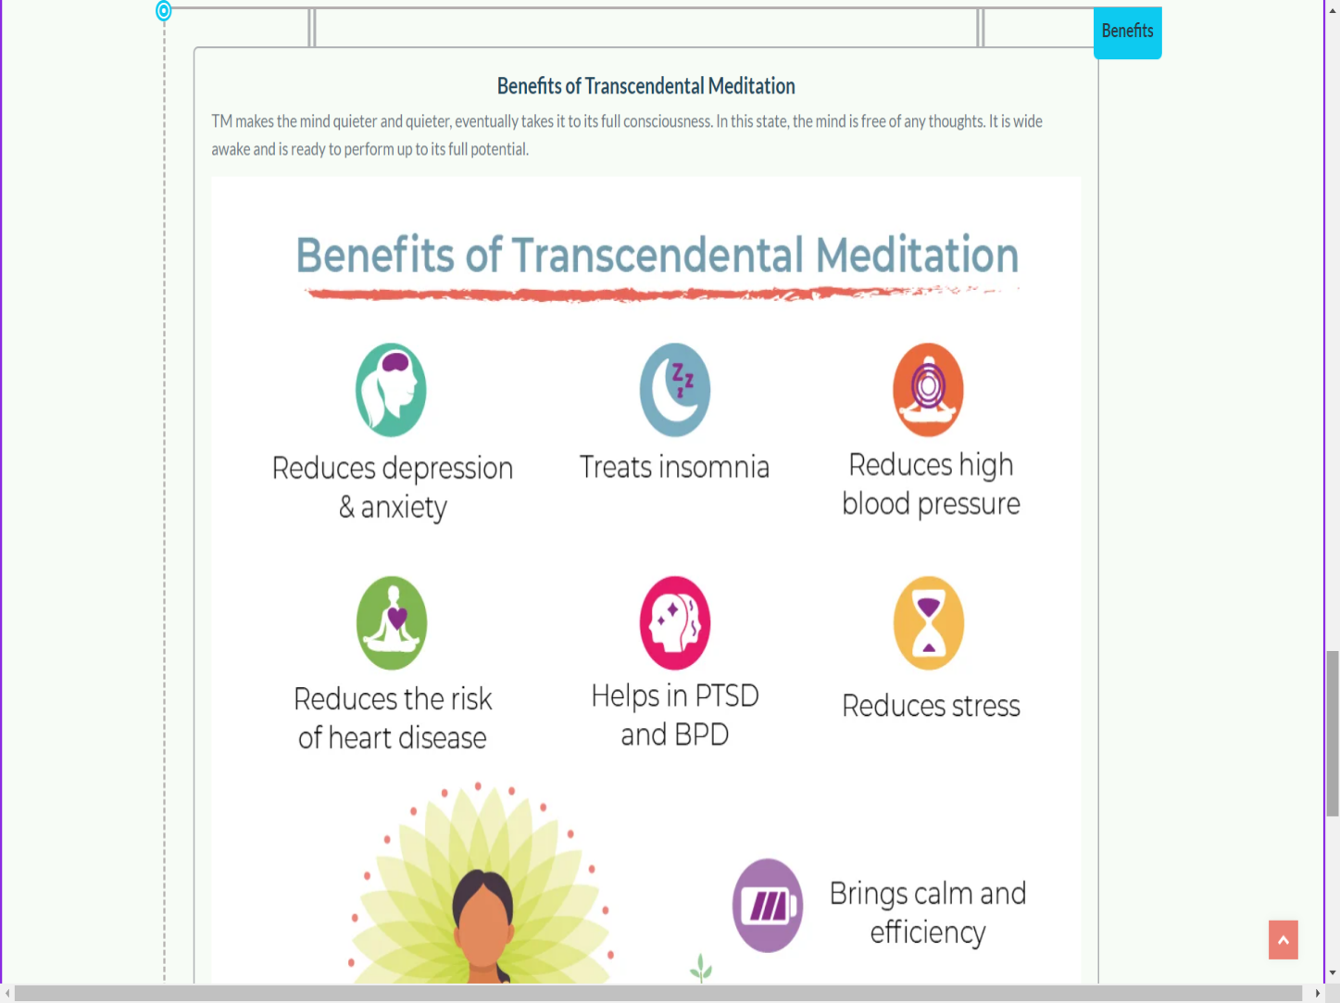

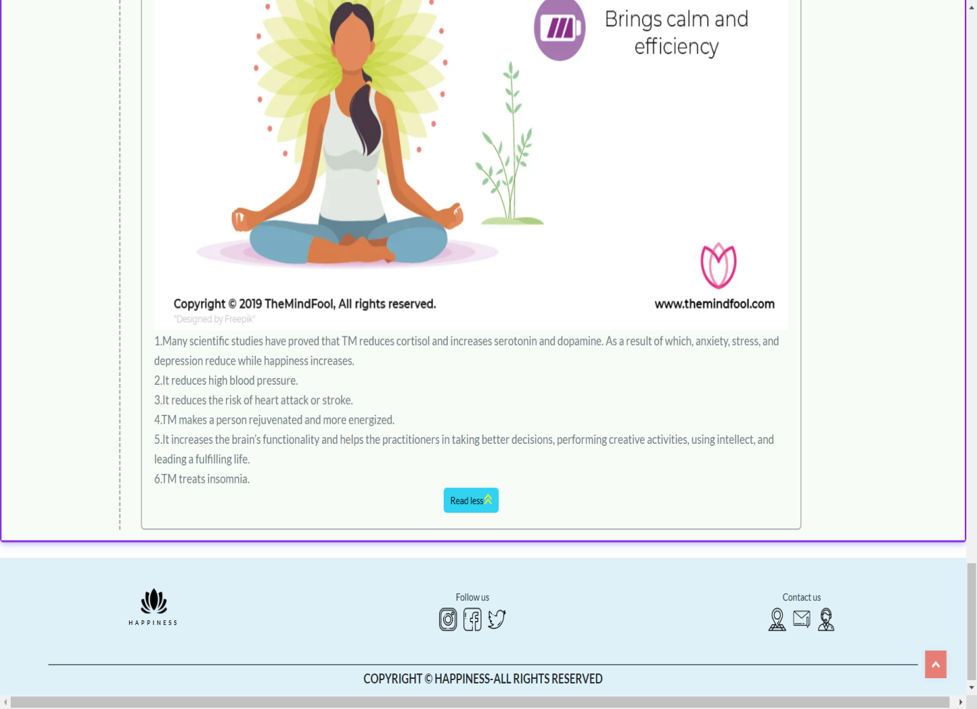

### Practice(Books)

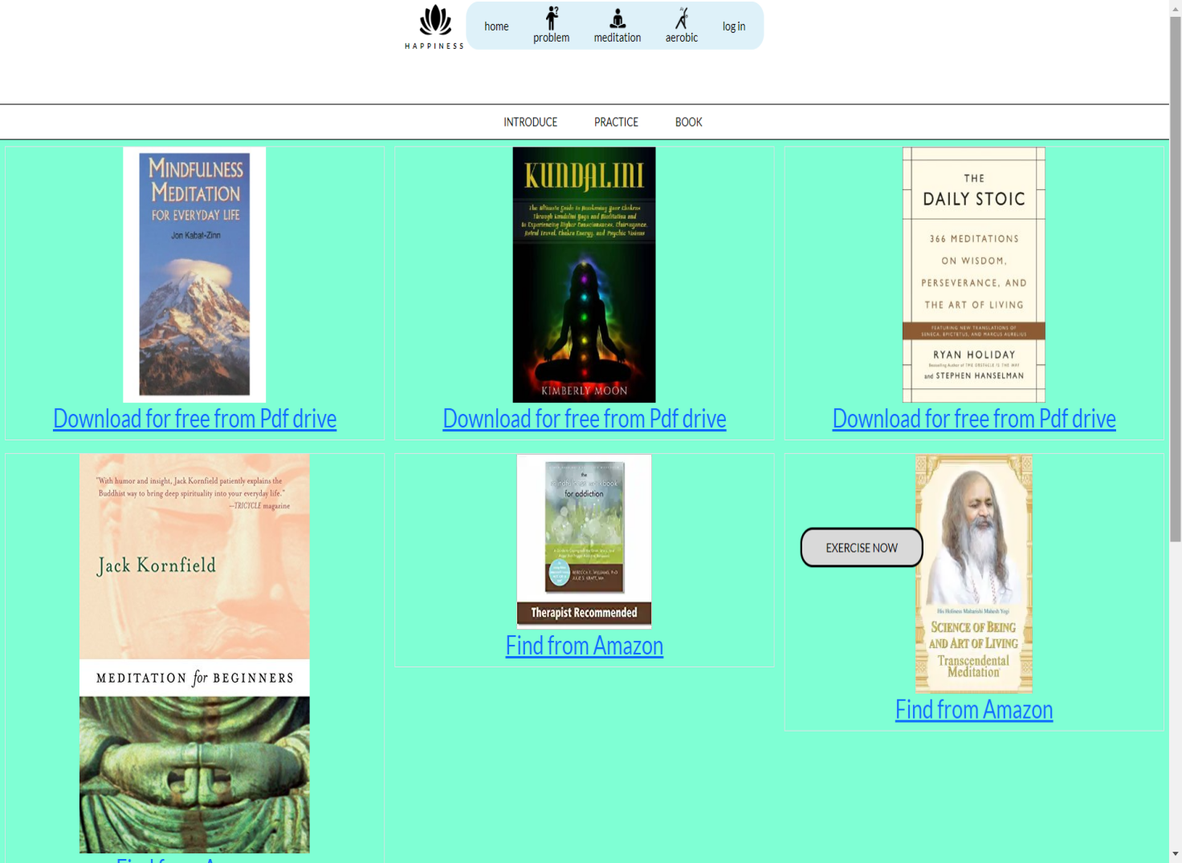

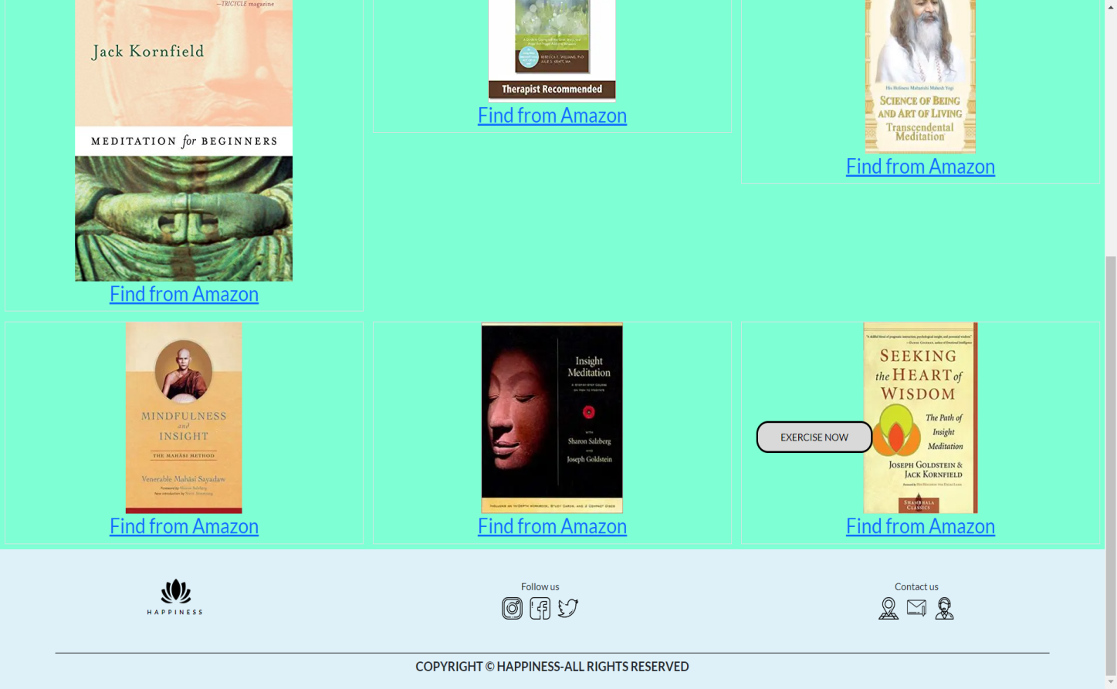

### Aerobic

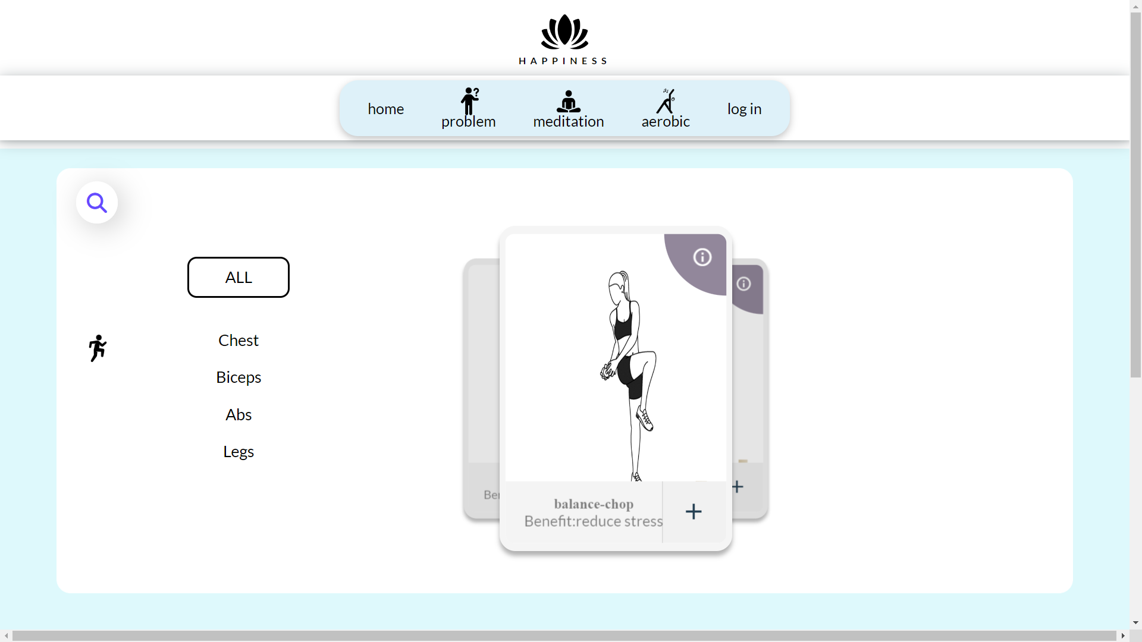

**Description**: To use aerobic we have a list of exercises and we will choose our favorite exercise.

### Aerobic(Add)

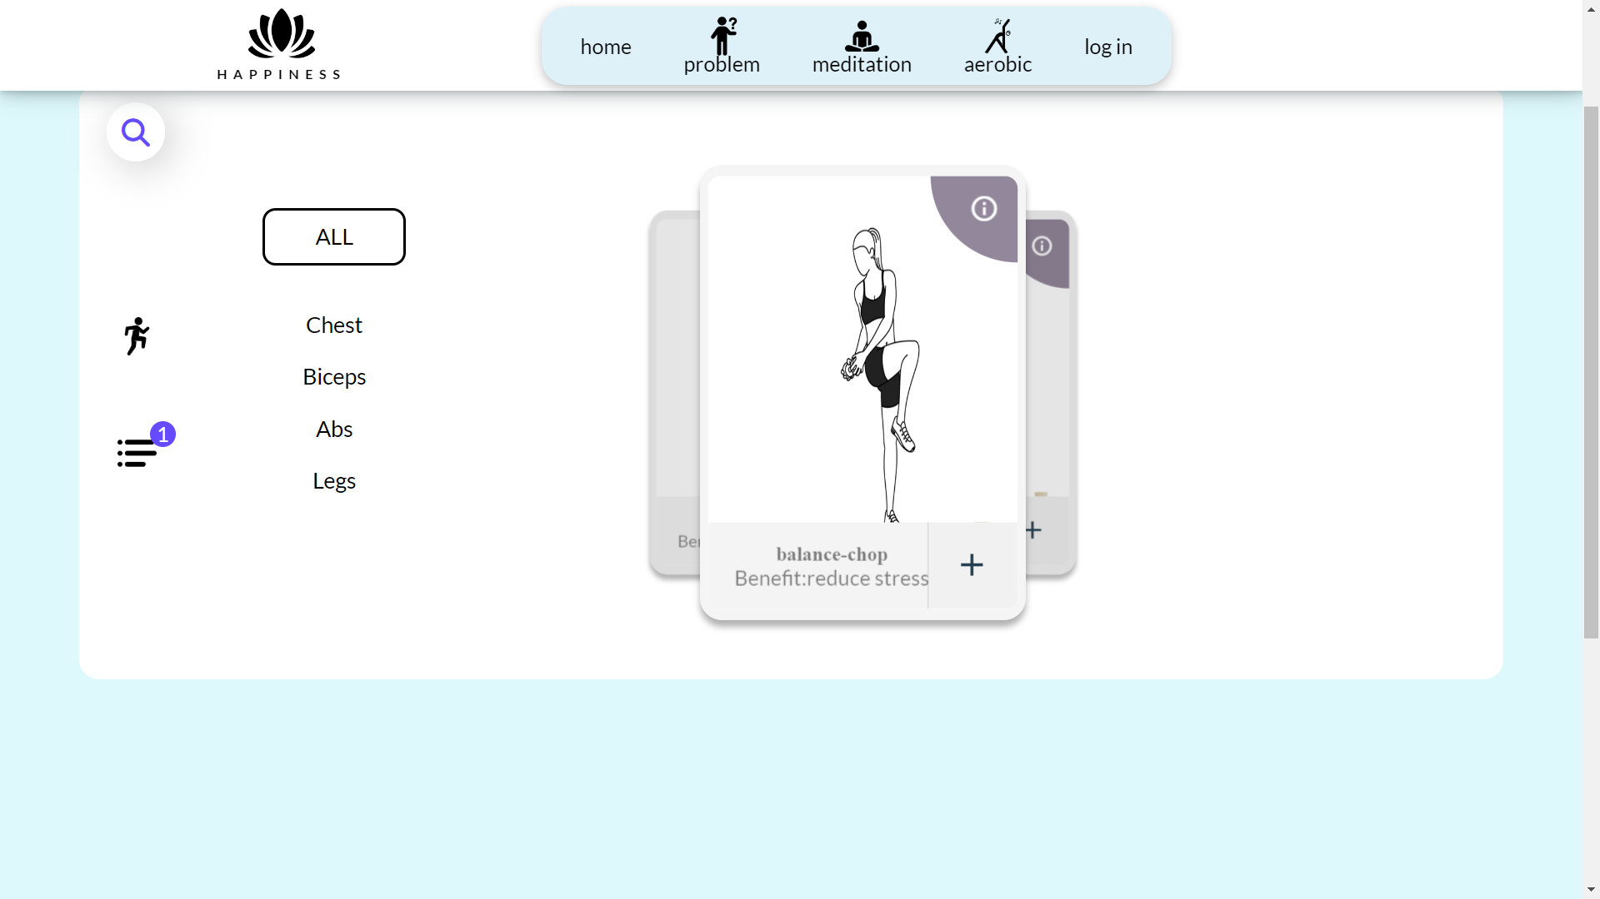

**Description**: Clicking on the plus sign the exercise we want to perform will appear a list on the left side of the screen.

### Aerobic(Let’s Practice)

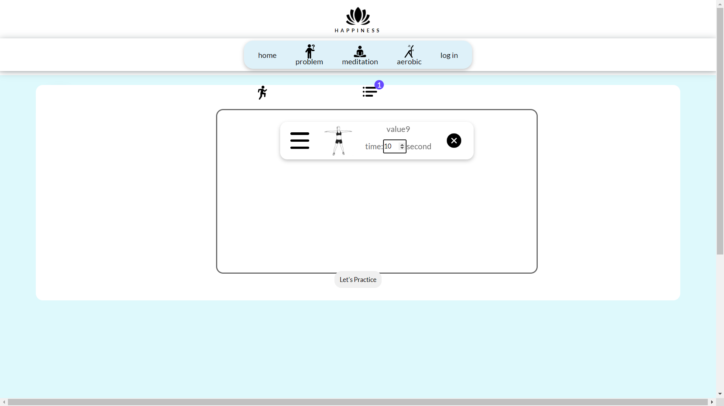

**Description**: Choose a time to practice and let's get started.

### Aerobic(Get Ready)

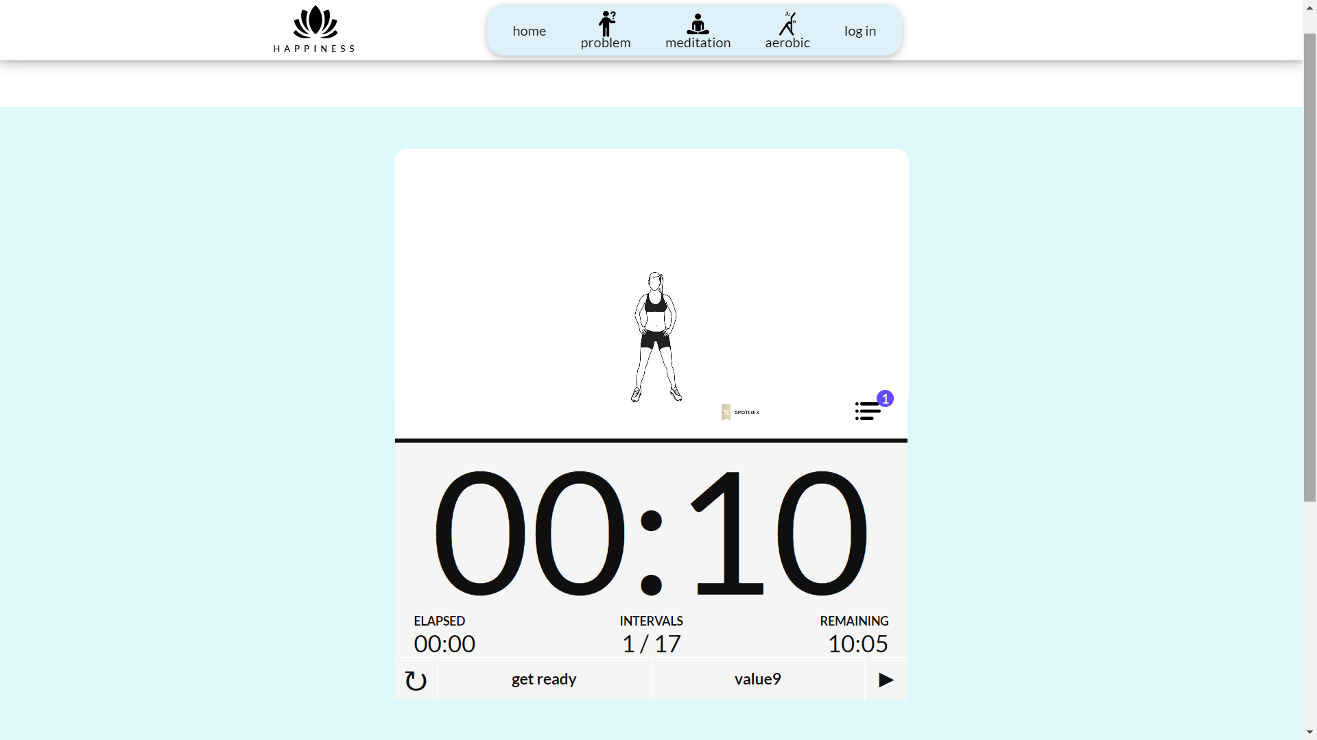

**Description:** Wish everyone good health and happiness after practicing.

## Task Sheet

|  |  |  |  |  |  |  |
| --- | --- | --- | --- | --- | --- | --- |
| **Project Ref No.** | **Project Title – Ask Me Mobile** | **Activity Plan Prepared by** | **Date of preparation of Activity Plan** | | | |
| **Task** | **Actual Start Date** | **Actual Days** | **Teammate Names** | **Status** |
| Brainstorming ideas for layouts and Project Object | | Hiển, Khải, Phát | 28/10/2022 | 1 days | Hiển, Phát, Khải | Completed |
| Draw site maps and architecture design | | Hiển, Phát, Khải | 30/10/2022 | 1 days | Hiển, Phát, Khải | Completed |
| Wire framing general page layout | | Phát | 2/11/2022 | 3 days | Phát | Completed |
| Collect static assets (pictures, mp4, documentation,…) | | Phát | 5/11/2022 | 2 days | Phát | Completed |
| Design & Build Homepage | | Khải | 06/11/2022 | 5 days | Khải | Completed |
| Design & Build Sign in | | Khải | 06/11/2022 | 5 days | Khải | Completed |
| Design & Build Sign up | | Phát | 10/11/2022 | 5 days | Phát | Completed |
| Design & Build Problem | | Khải,Hiển | 10/11/2022 | 7 days | Khải,Hiển | Completed |
| Design & Build Meditation | | Hiển | 12/04/2022 | 7 days | Hiển | Completed |
| Design & Build Aerobic | | Phát | 15/04/2022 | 10 days | Phát | Completed |

## Testing document

|  |  |  |  |  |
| --- | --- | --- | --- | --- |
| **Sr.No** | **Features Tested** | | | **Remarks** |
| 1 | Are all the users able to view the images and links? | | | OK |
| 2 | Have all the views, modules and controllers been | |  | OK |
| properly integrated and is the site function as a single | | |
| page application? | |  |
| 3 | Are the GUI content devoid of spelling mistakes? | | | OK |
| 4 | Is the application user-friendly? | | | OK |
| 5 | Is the Website launching correctly in all popular | |  | OK |
| browsers? |  |  |
| 6 | Are all the forms validated with proper criteria? | | | OK |
| 7 | Do all text links lead to the appropriate website? | | | OK |
| 8 | Do all image links lead to the appropriate website? | | | OK |
| 9 | Are all the images and links clearly visible on the page? | | | OK |
| 10 | Does the Web page work properly in all the tested | |  | OK |
| browsers? |  |  |
| 11 | Does the Web page take too long to be loaded fully? | | | OK |
| 12 | Is the navigation sequences correct through all the Web | | | OK |
| pages on the site? | |  |
| 13 | Is the JavaScript code working as expected in all click | | | OK |

## Final checklist

|  |  |  |  |  |
| --- | --- | --- | --- | --- |
| **Sr.No** | **Features Tested** | | | **Remarks** |
| 1 | Are all the users able to view the images and links? | | | OK |
| 2 | Have all the views, modules and controllers been | |  | OK |
| properly integrated and is the site function as a single | | |
| page application? | |  |
| 3 | Are the GUI content devoid of spelling mistakes? | | | OK |
| 4 | Is the application user-friendly? | | | OK |
| 5 | Is the Website launching correctly in all popular | |  | OK |
| browsers? |  |  |
| 6 | Are all the forms validated with proper criteria? | | | OK |
| 7 | Do all text links lead to the appropriate website? | | | OK |
| 8 | Do all image links lead to the appropriate website? | | | OK |
| 9 | Are all the images and links clearly visible on the page? | | | OK |
| 10 | Does the Web page work properly in all the tested | |  | OK |
| browsers? |  |  |
| 11 | Does the Web page take too long to be loaded fully? | | | OK |
| 12 | Is the navigation sequences correct through all the Web | | | OK |
| pages on the site? | |  |
| 13 | Is the JavaScript code working as expected in all click | | | OK |